Special Educational Needs and Disabilities (SEND) information report

Landscove CofE Primary School

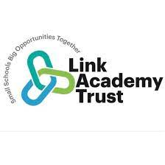

Approved by: | Link EIT | Date: 10.10.23
Last reviewed on: | 15th November 2023
Next review due by: | 31st October 2024

Contents
Contents 3
1. What types of SEN does the school provide for? 4
2. Which staff will support my child, and what training have they had? 4
3. What should I do if I think my child has SEN? 6
4. How will the school know if my child needs SEN support? 6
5. How will the school measure my child’s progress? 7
6. How will I be involved in decisions made about my child’s education? 7
7. How will my child be involved in decisions made about their education? 8
8. How will the school adapt its teaching for my child? 8
9. How will the school evaluate whether the support in place is helping my child? 9
10. How will the school resources be secured for my child? 10
11. How will the school make sure my child is included in activities alongside pupils who don’t have SEND? 10
12. How does the school make sure the admissions process is fair for pupils with SEN or a disability? 10
13. How does the school support pupils with disabilities? 11
14. How will the school support my child’s mental health and emotional and social development? 11
15. What support will be available for my child as they transition between classes or settings or in preparing for adulthood? 11
16. What support is in place for looked-after and previously looked-after children with SEN? 12
17. What should I do if I have a complaint about my child’s SEN support? 12
18. What support is available for me and my family? 13
19. Glossary 13

The aim of this information report is to explain how we implement our SEND policy. In other words, we want to show you how SEND support works in our school.
If you want to know more about our arrangements for SEND, read our SEND policy. You can find it on our website https://www.landscove.thelink.academy/web/send_policy/557339
Note: If there are any terms we’ve used in this information report that you’re unsure of, you can look them up in the Glossary at the end of the report.

1. What types of SEN does the school provide for?
Our school provides for pupils with the following needs:
Area of need | Condition
Communication and interaction | Autism spectrum condition
 | Developmental Language Disorder
 | Speech and language difficulties
Cognition and learning | Specific learning difficulties, including dyslexia, dyspraxia, dyscalculia
 | Moderate or severe learning difficulties
Social, emotional and mental health | Attention deficit hyperactive disorder (ADHD)
 | Attention deficit disorder (ADD)
 | Anxiety disorders
Sensory and/or physical | Hearing impairments
 | Visual impairment
 | Multi-sensory impairment
 | Physical impairment

2. Which staff will support my child, and what training have they had?
Within Link Academy Trust we have the support from the Improvement and Inclusion Hub (IIH), these are teachers and professionals with specific skills and expertise who support our school based SENCos. You can find out more about their work and staff here: https://www.thelink.academy/web/inclusion__improvement_hub/557170

Our special educational needs co-ordinator, or SENCO
Our SENDCO, Rosina Kellman, has 6 years’ experience in this role and has completed her National SENDCo Award in XXXXXX. She has worked as a Class Teacher, THRIVE Practitioner and Registered Nurse. The SENDCO is allocated 3 hours a week to manage SEND provision.

To contact Rosina, please e-mail adminlandscove@thelink.academy (Marked as CONFIDENTIAL - FAO: Rosina Kellman)
Our SEND lead, in school day to day, I sJill Ryder and she has 17years experience in this role and has worked alongside primary school children for 34 years. To Contact Jill please email adminlandscove@thelink.academy or jill.ryder@thelink.academy
Within the academy we also have Fran McLoughlin (Trust Inclusion Director) and Rebecca Humphreys (Inclusion Hub Manager) who have both completed their National SENDCo Award. Rebecca supports SEND at our school.
Class/subject teachers
All of our teachers receive in-house SEN training, and are supported by the SENCO to meet the needs of
pupils who have SEN. They are also supported through the work of the IIH and access support and training.
Our teachers are all working through the Devon Relational Approach training.
Teaching assistants (TAs)
We have a team of 4TAs, including 2 higher-level teaching assistants (HLTAs) who are trained to deliver SEN provision.
We have 2 teaching assistants who are trained to deliver interventions such as [We have 2 teaching assistants who are trained to deliver interventions such as Precision Teaching, Phonics Catch Up, Colourful Semantics, Lego Therapy, Early Reading Phonics, FunFit, Teodorescu and Dyslexia programmes.
In the last academic year, TAs have been trained in Relational Approaches, Autism, Precision Teaching, Phonics catch Up, Speech Language & Communication needs, Strategies for teaching of the deaf & hearing impaired, and have worked along specialist to tailor support to meet individual needs.
External agencies and experts
Sometimes we need extra help to offer our pupils the support that they need. Whenever necessary we will work with external support services to meet the needs of our pupils with SEN and to support their families. These include:
- Speech and language therapists
- Educational psychologists (through the ‘MAST’ team)
- Occupational therapists
- GPs or paediatricians
- School nurses
- Child and adolescent mental health services (CAMHS)
- Communication and Interaction Team – Babcock/DES
- Deaf and Hearing Impairment Team - DES
- Attendance Improvement Officer
- Social services and other LA-provided support services
- Voluntary sector organisations
- Link Academy Trust IIH team

3. What should I do if I think my child has SEN?

If you think your child might have SEND, the first person you should tell is your child’s teacher.  To make contact please speak to the school office to arrange an appointment.  They will pass the message on to our SENCO, who will be in touch to discuss your concerns.  You can also contact the SENCO directly, using the details published above. | We will meet with you to discuss your concerns and try to get a better understanding of what your child’s strengths and difficulties are.  Together we will decide what outcomes to seek for your child and agree on next steps.  We will make a note of what’s been discussed and add this to your child’s record. You will also be given a copy of this on request. | If we decide that your child needs SEN support, we will discuss this with you and your child will be added to the school’s SEND register. Your child will then have outcomes recorded on a provision map and you will receive a copy of this.

4. How will the school know if my child needs SEN support?
All our class teachers are aware of SEND and are on the lookout for any pupils who aren’t making the expected level of progress in their schoolwork or socially. This might include a delay in their social skills, communication, reading, writing or number work or difficulties with focus and attention.
If the teacher notices that a pupil is falling behind, they try to find out if the pupil has any gaps in their learning. If they can find a gap, they will give the pupil extra support to try to fill it. Pupils who don’t have SEN usually make progress quickly once the gap in their learning has been filled.
If the pupil is still struggling to make the expected progress, the teacher will talk to the SENCO, and will contact you to discuss the possibility that your child has SEN.
The SENCO will observe the pupil in the classroom and in the playground to see what their strengths and difficulties are. They will have discussions with your child’s teacher/s, to see if there have been any issues with, or changes in, their progress, attainment or behaviour. They will also compare your child's progress and development with their peers and available national data.
The SENCO will ask for your opinion and speak to your child to get their input as well. They may also, where appropriate, ask for the opinion of external experts such as a speech and language therapist, an educational psychologist, or a paediatrician, but this will always be done with your consent and knowledge.
Based on all of this information, the SENCO will decide whether your child needs SEN support. You will be informed of this decision.
If your child does need SEN support, their name will be added to the school’s SEND register, and the SENCO will work with you to create a SEN support plan for them in the form of a provision map.

5. How will the school measure my child’s progress?
We will follow the ‘graduated approach’ to meeting your child’s SEN needs.
The graduated approach is a 4-part cycle of assess, plan, do, review. This cycle can be repeated as required.
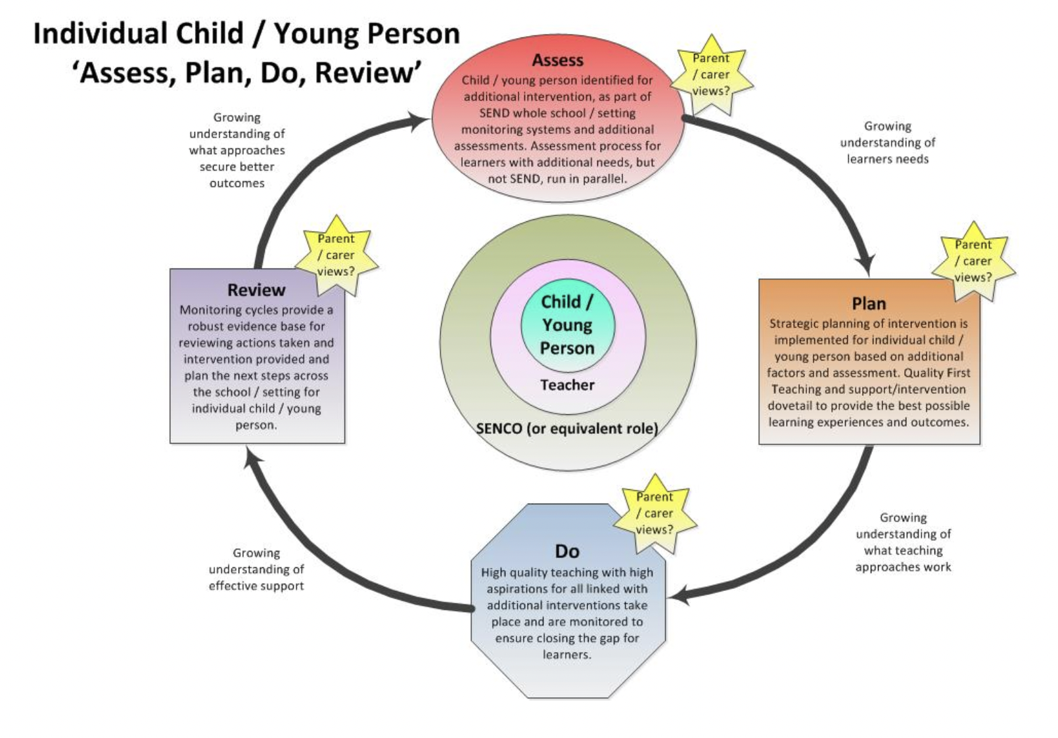

As a part of the planning stage of the graduated approach, we will set outcomes that we want to see your child achieve.
Whenever we run an intervention with your child, we will assess them before the intervention begins. This is known as a ‘baseline assessment’. We do this so we can see how much impact the intervention has on your child’s progress.
We will track your child’s progress towards the outcomes we set over time and improve our offer as we learn what your child responds to best.
This process will be continual. If the review shows a pupil has made progress, they may no longer need the additional provision made through SEN support. For others, the cycle will continue, and the school's targets, strategies and provisions will be revisited and refined.

6. How will I be involved in decisions made about my child’s education?
We will provide an annual written report on your child's progress.
Your child’s class teacher will meet you regularly (termly or as required), to:
- Set clear outcomes for your child’s progress
- Review progress towards those outcomes
- Discuss the support we will put in place to help your child make that progress
- Identify what we will do, what we will ask you to do, and what we will ask your child to do
The SENCO may also attend these meetings to provide extra support where requested.
We know that you’re the expert when it comes to your child’s needs and aspirations. We want to make sure you have a full understanding of how we’re trying to meet your child’s needs, so that you can provide insight into what you think would work best for your child.
We also want to hear from you as much as possible so that we can build a better picture of how the SEN support we are providing is impacting your child outside of school.
If your child’s needs or aspirations change at any time, please let us know right away so we can keep our provision as relevant as possible.
After any discussion we will make a record of any outcomes, actions and support that have been agreed. This record will be shared with all relevant staff, and you will be given a copy.
If you have concerns that arise between these meetings, please contact your child’s class teacher.

7. How will my child be involved in decisions made about their education?
The level of involvement will depend on your child’s age, and level of competence. We recognise that no two children are the same, so we will decide on a case-by-case basis, with your input.
We may seek your child’s views by asking them to:
- Attend meetings to discuss their progress and outcomes
- Prepare a presentation, written statement, video, drawing, etc.
- Discuss their views with a member of staff who can act as a representative during the meeting
- Complete a survey

8. How will the school adapt its teaching for my child?
Your child’s teachers are responsible and accountable for the progress and development of all the pupils in their class.
High-quality teaching is our first step in responding to your child’s needs. We will make sure that your child has access to a broad and balanced curriculum in every year they are at our school.
We will differentiate (or adapt) how we teach to suit the way the pupil works best. There is no 'one size fits all’ approach to adapting the curriculum, we work on a case-by case basis to make sure the adaptations we make are meaningful to your child.
These adaptations include:
- Differentiating our curriculum to make sure all pupils are able to access it, for example, by grouping, 1-to-1 work, adapting the teaching style or content of the lesson, etc.
- Differentiating our teaching, for example, giving longer processing times, pre-teaching of key vocabulary, reading instructions aloud, offering visuals and concrete resources etc.
- Adapting our resources and staffing
- Using recommended aids, such as laptops, coloured overlays, visual timetables, larger font, etc.
- Teaching assistants will support pupils on a 1-to-1 basis when there is an identified need that can’t be otherwise met; this may often be because they have an intervention requested by an external professional such as an OT or speech & language therapist. As a rule, children do not access 1-1 support even with an EHCP unless there is a clear rationale for this.
- Teaching assistants will support pupils in small groups when they need to deliver an intervention that requires a more focussed approach, this may take place outside the classroom.
We may also provide the following interventions:

Area of need | Condition | How we support these pupils
Communication and interaction | Autism spectrum disorder | Visual timetables  Social stories  Relational Support Plan  Calm learning environment with reduced sensory overload  Ear defenders
 | Speech and language difficulties | Speech and language therapy  Pre-teaching  Colourful Semantics  Widgets
Cognition and learning | Specific learning difficulties, including dyslexia, dyspraxia and dyscalculia | Writing slope  Use of a laptop/tablet  Spelling lists and dictionaries  Coloured overlays  Calm learning environment with reduced sensory overload  FunFit
 | Moderate learning difficulties | Specialist support from external  agencies
 | Severe learning difficulties | Specialist support from external  agencies
Social, emotional and mental health | ADHD, ADD | Quiet workspace  Fiddle objects  Movement breaks
 | Adverse childhood experiences and/or mental health issues | Nurture group  ELSA (emotional learning support assistant)  Access to IIH woodland  Relational Support Plan
Sensory and/or physical | Hearing impairment | Specialist support from external agencies  Mic packs  Use of Makaton or BSL
 | Visual impairment | Limiting classroom displays to avoid overload
 | Multi-sensory impairment | Specialist support from external agencies
 | Physical impairment | Sufficient space in classroom for safe access

These interventions are part of our contribution to Devon’s local offer.

9. How will the school evaluate whether the support in place is helping my child?
We will evaluate the effectiveness of provision for your child by:
- Reviewing their progress towards their goals each term
- Reviewing the impact of interventions after the maximum of one term
- Using pupil questionnaires
- Monitoring by the SENCO
- Using provision maps to measure progress
- Holding an annual review (if they have an education, health and care (EHC) plan)

10. How will the school resources be secured for my child?
It may be that your child’s needs mean we need to secure:
- Extra equipment or facilities
- More teaching assistant hours
- Further training for our staff
- External specialist expertise
If that’s the case, we will consult with external agencies to get recommendations on what will best help your child access their learning.
The school has funding in its budget to support children with additional needs. In Link Academy Trust the majority of this funding is shared across the MAT and is used to secure staffing (such as teaching assistants), to give release time to SENCOs, to access external support that charge for their services to schools, such as Educational Psychologists and to develop and support the work of the IIH. If funding is needed beyond this, we will endeavour to seek it from our local authority.

11. How will the school make sure my child is included in activities alongside pupils who don’t have SEND?
All of our extra-curricular activities and school visits are available to all our pupils, including our before and after-school clubs.
All pupils are encouraged to go on our school trips, including our residential trips and we will make adjustments wherever possible to ensure this. All pupils are encouraged to take part in sports day, school plays, special workshops etc. and where we are unsure of suitability this will be discussed with the parent.
No pupil is ever excluded from taking part in these activities because of their SEN or disability and we will make whatever reasonable adjustments are needed to make sure that they can be included.

12. How does the school make sure the admissions process is fair for pupils with SEN or a disability?
The Link Academy Trust is our admissions authority. All admissions are dealt with fairly and in line with the Admissions Code, this includes that all prospective pupils whose EHC plan names the school will be admitted before any other places are allocated. Link ensure that our oversubscription criteria avoid unfairly disadvantaging prospective pupils with a disability or special educational needs. The school’s admissions policy can be found here ( https://www.landscove.thelink.academy/web/admissions/388439 ) on the school website or by request to the school and includes details of how to appeal.

13. How does the school support pupils with disabilities?
- No child is prevented from accessing our school or it’s curriculum. We work alongside specialist support from external agencies whenever needed to ensure this is the case.
- We have disabled toilets, shower, ramps in the playground and do what ever is required to give disabled pupils access to our school, including the provision of auxiliary aids and services
- Our school’s accessibility plan can be found here: https://www.landscove.thelink.academy/web/accessibility_plan/557338
- It covers how we will:
  - Increase the extent to which disabled pupils can participate in the curriculum
  - Improve the physical environment to enable disabled pupils to take better advantage of the education, benefits, facilities and services you provide
  - Improve the availability of accessible information to disabled pupils

14. How will the school support my child’s mental health and emotional and social development?
We provide support for pupils to progress in their emotional and social development in the following ways:
Pupils with SEND are encouraged to be part of the school council and other roles of responsibility
We provide extra pastoral support for listening to the views of pupils with SEND (e.g. through our
Relational support)
We have a ‘zero tolerance’ approach to bullying. We prevent bullying in the school by educating the children on what bullying is through assemblies and our PSHE scheme Jigsaw, supporting children to know how to share concerns with a restorative and relational approach and working closely with parents when they raise concerns. We also work with agencies such as the NSPCC and CAP to provide the children with practical workshops on bullying.
All staff have trained in the Relational Approach where we put relations at the heart of school life and use compassion and an understanding of regulation to support all pupils

15. What support will be available for my child as they transition between classes or settings?
Between years
To help pupils with SEND be prepared for a new school year we:
- Ask both the current teacher and the next year’s teacher to attend a meeting at the end of the year when the pupil’s SEN strengths and needs are discussed.
- We timetable transition sessions so that towards the end of the summer term children spend time in their new class.
Between schools
When your child is moving on from our school, we will ask you and your child what information you want us to share with the new setting. All records will be passed to the receiving school as soon as possible and in line with GDPR.
Between phases
The SENCO of the secondary school will contact our school for a meeting with our SENCO. They will discuss the needs of all the children who are receiving SEN support.
Pupils will be prepared for the transition by:
- Discussing a secondary school timetable
- Learning how to get organised independently.
- Where possible they will attend an enhanced transition and have additional visits

16. What support is in place for looked-after and previously looked-after children with SEND?
Jill Ryder will work with our SENCO, to make sure that all teachers understand how a looked-after or previously looked-after pupil’s circumstances and their SEN might interact, and what the implications are for teaching and learning. We are also supported by Devon's Virtual School, further information can be found here or speak to us in school https://www.devon.gov.uk/educationandfamilies/young-people/children-in-care/education-of-children-in-care/
Children who are looked-after or previously looked-after will be supported much in the same way as any other child who has SEND. However, looked-after pupils will also have a personal education plan (PEP). We will make sure that the PEP and any SEN support plans or EHC plans are consistent and complement one another.

17. What should I do if I have a complaint about my child’s SEN support?
Our school’s complaints procedure can be found here on our website. https://www.landscove.thelink.academy/web/policies/388309
Complaints about SEN provision in our school should be made to the SENCO and/or headteacher in the first instance. They will then be referred to the school’s complaints policy.
If you are not satisfied with the school’s response, you can escalate the complaint. In some circumstances, this right also applies to the pupil themselves.
To see a full explanation of suitable avenues for complaint, see pages 246 and 247 of the SEN Code of Practice.
If you feel that our school discriminated against your child because of their SEND, you have the right to make a discrimination claim to the first-tier SEND tribunal. To find out how to make such a claim, you should visit: https://www.gov.uk/complain-about-school/disability-discrimination
You can make a claim about alleged discrimination regarding:
- Admission
- Exclusion
- Provision of education and associated services
- Making reasonable adjustments, including the provision of auxiliary aids and services
Before going to a SEND tribunal, you can go through processes called disagreement resolution or mediation, where you try to resolve your disagreement before it reaches the tribunal.
Contact details of the disagreement resolution and mediation services for Devon are: Global Mediation and you can contact them on 0800 064 4488 or email sen@globalmediation.co.uk to find out more.

18. What support is available for me and my family?
If you have questions about SEND, or are struggling to manage and understand your child’s needs, please get in touch to let us know. We want to support you, your child and your family.
To see what support is available to you locally, have a look at Devon’s local offer
https://www.devon.gov.uk/education-and-families/send-local-offer/
Our local special educational needs and disabilities information advice and support services (SENDIASS) organisations are able to give impartial and confidential support to families. They can be contacted at : https://devonias.org.uk/ or on 01392 383080
National charities that offer information and support to families of children with SEND are:
- IPSEA
- SEND family support
- NSPCC
- Family Action
- Special Needs Jungle

19. Glossary
- Access arrangements – special arrangements to allow pupils with SEND to access assessments or exams
- Annual review – an annual meeting to review the provision in a pupil’s EHC plan
- Area of need – the 4 areas of need describe different types of needs a pupil with SEND can have. The 4 areas are communication and interaction; cognition and learning; physical and/or sensory; and social, emotional and mental health needs.
- CAMHS – child and adolescent mental health services
- Differentiation – when teachers adapt how they teach in response to a pupil’s needs
- EHC needs assessment – the needs assessment is the first step on the way to securing an EHC plan. The local authority will do an assessment to decide whether a child needs an EHC plan.
- EHC plan – an education, health and care plan is a legally-binding document that sets out a child’s needs and the provision that will be put in place to meet their needs. These are issued by the local authority.
- First-tier tribunal/SEND tribunal – a court where you can appeal against the local authority’s decisions about EHC needs assessments or plans and against discrimination by a school or local authority due to SEND
- Graduated approach – an approach to providing SEN support in which the school provides support in successive cycles of assessing the pupil’s needs, planning the provision, implementing the plan, and reviewing the impact of the action on the pupil
- Intervention – a short-term, targeted approach to teaching a pupil with a specific outcome in mind
- Local offer – information provided by the local authority which explains what services and support are on offer for pupils with SEN in the local area
- Outcome – target for improvement for pupils with SEND. These targets don't necessarily have to be related to academic attainment
- Reasonable adjustments – changes that the school must make to remove or reduce any disadvantages caused by a child’s disability
- SENCO – the special educational needs co-ordinator
- SEN – special educational needs
- SEND – special educational needs and disabilities
- SEND Code of Practice – the statutory guidance that schools must follow to support children with SEND
- SEN information report – a report that schools must publish on their website, that explains how the school supports pupils with SEN
- SEN support – special educational provision which meets the needs of pupils with SEN
- Transition – when a pupil moves between years, phases, schools or institutions or life stages

