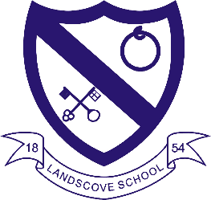
LANDSCOVE C OF E PRIMARY SCHOOL
RE & CW Lead Report for the School Ethos Group

This term:
26.9.22 Harvest in a Day – Pumpkin craft, apple picking dance, musical accompaniments for our story, fruit and vegetable riddles.
4.10.22 Harvest service in St. Matthew’s. Generous donations made to our local food bank.
18.10.22 AN attended RE Hub Meeting.

Class three and four children have created work for World Views Displays.
RE units being taught this half term:
Class 1: Being Special: Where do we belong?
Class 2: Who is a Muslim and how do they live?
Class 3: What do Hindus believe God is like?
Class 4: Why do Hindus want to be good?
We are focusing on developing Talk Roles when exploring big questions and always look for creative ways in which the children can learn and express their ideas (e.g., through dance, drama, art and written activities)

Collective Worship
Core Value: responsibility
Visiting Values: Thankfulness and generosity (linking to Harvest)
British Value: Tolerance

Sally Watson from Open the Book comes in fortnightly. She has covered the following Bible stories:
In the Beginning (Creation)
A Special Promise (Noah)
The Burning Bush (Moses)
Children from classes 3 and 4 have the opportunity to take acting/speaking parts.

Upcoming events
Week beginning 13th November: Interfaith Week
Nativities, Christingle and Carols in St Matthew’s.

Strand Two: WISDOM KNOWLEDGE AND SKILLS (meeting academic and spiritual needs of learners).
Please see separate document and have questions ready.

LANDSCOVE C OF E PRIMARY SCHOOL
Academy Head Report for the School Ethos Group

PUPIL NUMBERS

R 15
Y1 13
Y2 17
Y3 13
Y4 13
Y5 8
Y6 13
Total 92

CLASS ORGANISATION
- Class 1 : R (0.4 Rebecca Barons, 0.6 Jo Woods)
- Class 2: Y1 & Y2 (FT Jenny Foster)
- Class 3: Y3 & Y4 (Luke Ansermoz FT)
- Class 4: Y5 & Y6 (0.5 Anna Neville, 0.5 Anne Smart)

STAFFING UPDATES
- Nothing new to report

SCHOOL IMPROVEMENT PLAN & SCHOOL SELF EVALUATION:
We have started working on our key priorities through staff meetings, non-pupil day INSET & research by individual teachers
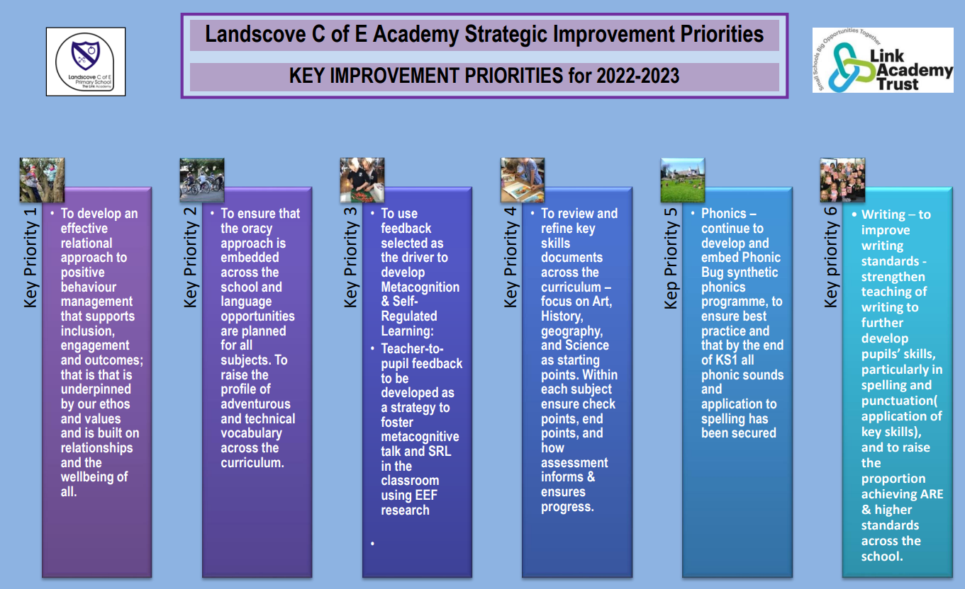

OTHER INFORMATION – VISITORS - COURSES ETC
- We have shown a number of prospective parents around school and some in term arrivals
- 5.10.22 Harvest festival – the first in church since 2019! Thanks to Anna Neville for organising the event and workshop day that led to our church service.
- 10.10.22: Arts week … no doubt running into a second week! Everyone thoroughly enjoys this week and this year have been working with Sandra Salter from Salty’s studio. Huge thanks to Anna Neville for organising this event and securing our artist
- 13.10.22 Y6 attended Junior Life skills @ Totnes Pavillions
- 11/13.10.22 Parents evenings
- 14.10.22 FOLS Movie night
- 18.10.22 Year 5/6 Tag Rugby Tournament @ Headlands with Mr Tanner
- 21.10.22 Class 3 Roman workshop day (with Y3/4 from Broadhempston)

HEALTH & SAEFTY/ SAFEGUARDING/ BEHAVIOUR/C19
- All staff have completed Level 2 safeguarding training
- Luke Ansermoz has completed Level 3 safeguarding training & I have completed a Level 3 refresher day.
- Attendance monitoring will take week beginning 17.10.22 and letters will be sent to parents if attendance is giving cause for concern.
- All staff have completed a variety of mandatory training: Cyber Security, Prevent, Health & Safety First Aid, Level Compliance inc KCSIEGDPR
- All staff have completed Forest school training – fire lighting & safe use of tools
- Devon County advisors completed a fire risk assessment for our school with Amanda Grant

Safeguarding training this half term is based on: Keeping Children safe in Education (KCSIE) and County lines.

Anna Neville & Jill Ryder

