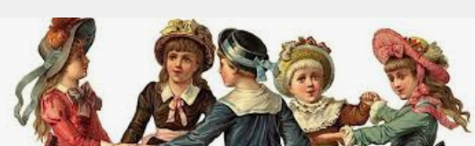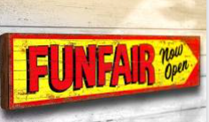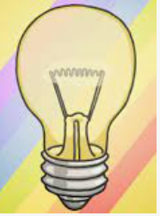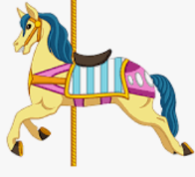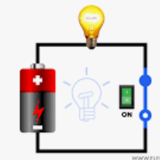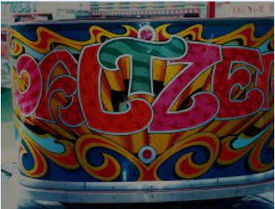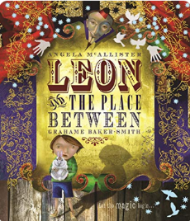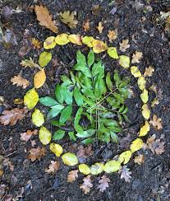

**ENGLISH:**

Leon and the Space Between by Grahame Baker – Smith.

Fantasy Story Writing

**WILD WOODLAND LEARNING**

**Team building activities.**

**Enjoying the outdoors, cooking, den-building and understanding more about nature.**

Enrichment

Victorian Day learning more about being a Victorian child.

Decoy Country Park – outdoor adventure day.

**Fun at the Fair – Summer Term**

**DT – Carousel**

Make a fairground ride with moving parts and an electrical circuit.

**PSHE**

**Relationships and Changing Me.**

**Spanish**

Alphabet, members of the family, pets, hobbies, transport, weather, clothes

COMPUTING

Programming using scratch.

GEOGRAPHY

How to live sustainably.

**ENGLISH:**

How to Invent: Information writing. Create a double page spread about a Victorian inventor and some inventions.

**SCIENCE – Electricity**

Learning about circuits, conductors, insulators and how to stay safe around electricity.

**SCIENCE – Light**

Can we see in the dark? How do shadows form?

**MATHS:**

* **Measurement**
* **Statistics**
* **Position and Direction**
* **Shape**

**RE –**  What kind of world did Jesus want?

How and why do religious people try to make the world a better place?

**ART**

Fairground Art in the style of Fred Fowle

**HISTORY**

Victorians – What was life like, for children living during Victorian times?

**PE**

Tennis, Athletics

MUSIC

Kapow unit