Equality & Diversity
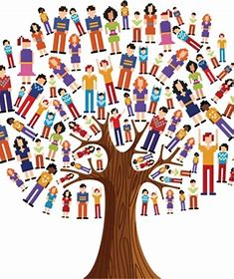
'Equality is about ensuring everybody has an equal opportunity and is not treated differently or discriminated against because of their characteristics.'
'Diversity is about taking account of the differences between people and groups of people and placing a positive value on those differences.'
At Landscove, we are committed to ensuring equality of opportunity for all pupils, staff, parents and carers irrespective of race, gender, disability, religion & belief, sexual orientation, marital status, pregnancy & maternity, age or socio-economic background. We aim to develop a culture of inclusion and diversity in which all those connected to the school feel proud of their identity and ability to participate fully in school life.
We tackle discrimination through the positive promotion of equality, by challenging bullying and stereotypes and by creating a safe, caring and positive environment for all.
We believe that diversity is a strength which should be respected and celebrated by all those who learn, teach and visit us.
Equality in Admissions and Exclusions
- Our admissions arrangements are fair and transparent and do not discriminate on the grounds of any protected characteristics.
Equality in Teaching and learning
We provide all our pupils with the opportunity to succeed and to reach their own level of personal achievement. We do this by:
- Ensuring equality of access for all pupils and preparing them for life in a diverse society
- Promoting attitudes and values that challenge any discriminatory behaviour or prejudice
- Providing opportunities for pupils to appreciate their own culture and celebrate the diversity of other cultures
- Encouraging the involvement of all parents in supporting their child’s education
- Using materials that reflect the diversity of the school, population and local community without stereotyping
Equal Opportunities for Staff
- All staff appointments and promotions are made on the basis of merit and ability and in compliance with the law.

