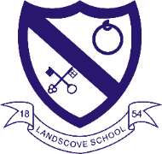
LANDSCOVE C OF E PRIMARY SCHOOL
RE & CW Lead Report for the School Ethos Group

Wednesday 3rd February 2021

SCHOOL ETHOS, SIAMS & RE
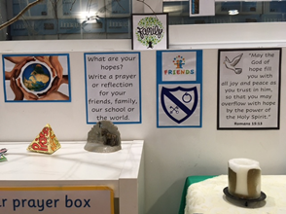
Reflective Space – Communicated via newsletter and Facebook.
Blended learning for FaB is in place for all classes
Current units being taught:
•EYFS: Being special: Where do we belong. Recorded lesson and follow up activity
•Class 2: Who is Muslim and how do they live? Assignments ~ follow up activities
•Class 3: What is it like to be a Hindu in Britain Today? Assignment and recording.
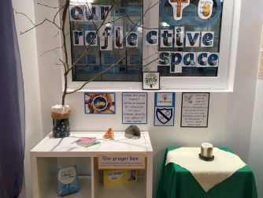
•Class 4: Creation: Science & Christianity: conflict or complementary. Assignments
Engagement levels:
•Class 2: 92%
•Class 3: 86%
•Class 4: 95%
•JR recording weekly Achievement Assemblies.
•25.1.21 AN recorded a CW on the theme of Hope.
•1.2.21 Helen Sands from Open the Book provided a recording of the Simeon story (Candlemas). Teachers shared with children on Teams. Shown to key worker children in school.
•1.2.21 AN attended a RE Hub meeting. Share good practice and support each other in blended learning.
Our theme for monitoring is COMMUNITY AND LIVING WELL TOGETHER (relationships, behaviour and mental health). See rest of report outlining provision in this area.

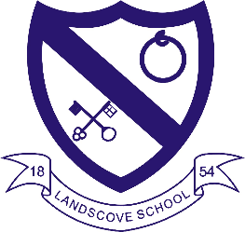
LANDSCOVE C OF E PRIMARY SCHOOL
Academy Head Report for the School Ethos Group

PUPIL NUMBERS

R 14
Y1 13
Y2 14
Y3 10
Y4 11
Y5 12
Y6 10
Total 84

CLASS ORGANISATION
- Class 1 : R (0.4 Lucy Field, 0.6 Jo Woods)
- Class 2: Y1 & Y2 (0.9 Jenny Foster, 0.1 Amanda Richardson)
- Class 3: Y3 & Y4 (0.5 Anna Neville, 0.5 Anne Smart)
- Class 4: Y5 & Y6 (Karen Barlow FT 0.1 Amanda Richardson)

Staffing updates
Jill currently Acting Executive Head for Landscove and Broadhempston. Review due at the end of academic year.

SCHOOL IMPROVEMENT PLAN & SCHOOL SELF EVALUATION:
Staff meetings continue to run via TEAMS. This half term we are concentrating on the following key priorities:
- KP2&3: WRITING To improve standards, progress and outcomes in writing & vocabulary development across both reading & writing
- KP5: Develop online learning for home access- platforms and ensure accessibility for all children, parents & staff. (KB is holding school based training & Vic Pooler is delivering further Trust level training)
We are currently offering:
- Live lessons, recorded lessons, Oak academy lessons
- Support via: Telephone contact with class teachers or TEAMS individual calls & small group calls
- 1:1/ small grp TA support made available to SEND/additional need/ EHCP chn both in school & via TEAMS
- Offering of paper learning packs
- Support in provision of IT equipment
- Invite chn in to school if struggling
- A survey was sent to gauge access & parent feedback around remote learning. Jill to analyse results and make adaptations to practice where possible.
- This half term staff are also completing book scrutiny’s to further develop knowledge of whole school strengths and development points in English
Safeguarding training this half term is based on:
- Brook Tool: Sexualised behaviours traffic light tool: Information & scenarios are used
- Green behaviours reflect safe and healthy sexual development. They are:
- displayed between children or young people of similar age or developmental ability
- reflective of natural curiosity, experimentation, consensual activities and positive choices
- Amber behaviours have the potential to be outside of safe and healthy behaviour. They may be:
- unusual for that particular child or young person
- of potential concern due to age, or developmental differences
- of potential concern due to activity type, frequency, duration or context in which they occur
You would now need to be informing you safeguarding officers.
- Red behaviours are outside of safe and healthy behaviour.They may be:
  - excessive, secretive, compulsive, coercive, degrading or threatening
  - involving significant age, developmental, or power differences
  - of concern due to the activity type, frequency, duration or the context in which they occur
  - Red behaviours indicate a need for immediate intervention and action.

SCHOOL COUNCIL & PLAY LEADERS
- Nothing to report at this point due lockdown.
OTHER INFORMATION – VISITORS - COURSES ETC
- IIH is supporting children and families with high levels of anxiety with home schooling and engagement.
- Team around the Family (TAF) meeting continue to run through lockdown.
- EP referrals continue to take place.

HEALTH & SAEFTY/ SAFEGUARDING/ BEHAVIOUR
- Covid19: We continue to take advice from the Dfe and Public health England alongside the lead for education in Devon. We have daily updates that enable us to keep up with developments and what is being asked of us.
- Academy heads work together with Nicky Dunford each week to maintain best practice for C19 and impact on school community.
- Risk assessments are in place and we are currently running 2 bubbles in school for vulnerable children and critical key workers. All risk assessments are checked at Trustee and Governor level.
- Lateral flow testing has been introduced for all staff in school. Results are reported to Government website and to Amanda Grant who holds a register at school level.
- Wellbeing of staff is also been a high priority at this time as they too have families to support either with home learning or in other ways.
- We maintain contact throughout lockdown with any vulnerable pupils and families. (TEAMS, email, phone, teachers, TAS & me!)
- Jill complete Mrs R’s Wednesday wellbeing activities each week – aim to consider more than academic learning- whole child.
- Children’s mental health week: activities across the week in support of this

Anna Neville & Jill Ryder

