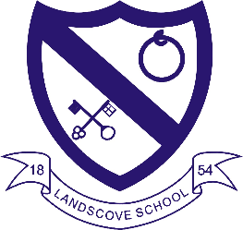
LANDSCOVE C OF E PRIMARY SCHOOL
RE & CW Lead Report for the School Ethos Group 27th Nov 2023

We raised £179.58 for the Poppy Appeal
7.11.23 Anna took Ethos Group to Buckfastleigh Food Bank
8.11.23 Anna and Jill attended SIAMS SEF Writing course
9.11.23 Anna attended RE Hub Meeting
14.11.23 Muslim Cultural Champion visit (Q&A sessions in Class 2 and 4, Muslim prayer in CW)
27.11.23 Spiritualty questions relating to Christmas explored in Gospel Groups
Upcoming Events:
Date tbc Class Three Trip to Exeter Mosque
11.3.23 Jewish Speaker in Class 4
Nativities and carols.
Global Neighbours Update
Anna liaising with Reverend Gina regarding a charity that aims to bring clean water to villages in Sierra Leone.
Eco Group to do an audit of single use plastic use and food waste in school.
Plans to enter Spirited Arts Competition https://www.natre.org.uk/about-natre/projects/spirited-arts/

SIAMS focus – Collective Worship
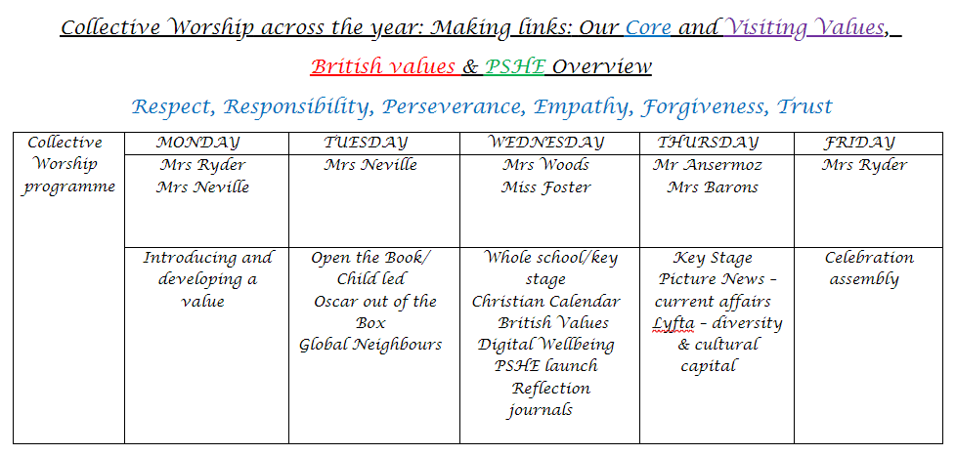
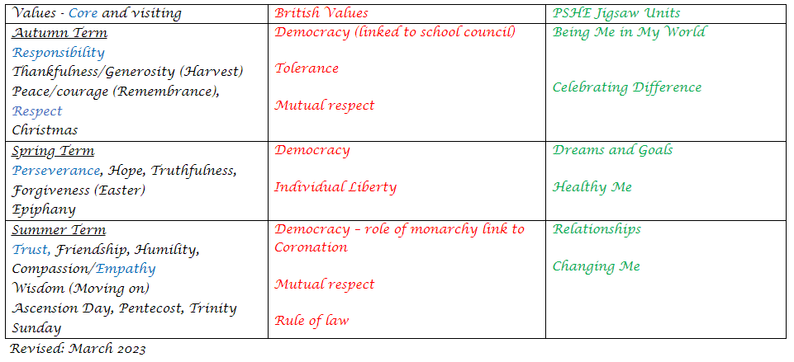
Measuring the Impact: Teachers evaluate the programme. Feedback gathered from staff, children and visitors.
Evident in children’s learning across the curriculum (reference to values in PSHE, Bible stories recalled in FaB lessons etc.)
AN to summarise recent feedback.
Share Collective Worship Sway.

LANDSCOVE C OF E PRIMARY SCHOOL
Academy Head Report for the School Ethos Group

PUPIL NUMBERS

R 7
Y1 14
Y2 16
Y3 15
Y4 14
Y5 11
Y6 7
Total 84

CLASS ORGANISATION
Class 1: R (0.4 Rebecca Barons, 0.6 Jo Woods)
Class 2: Y1 & Y2 (FT Jenny Foster)
Class 3: Y3 & Y4 (Luke Ansermoz FT)
Class 4: Y5 & Y6 (0.5 Anna Neville, 0.5 Jas Capaldi)

Amanda Richardson covers PPA across the school on a Wednesday and Friday.

STAFFING UPDATES
Miss Foster & Mrs Richardson will be leaving us at the end of term. The recruitment process is underway.
SCHOOL IMPROVEMENT PLAN & SCHOOL SELF EVALUATION:
Staff meetings this term have been linked to our school improvement plan. We have completed training, research, held discussions and adapted paperwork in the following areas:
- Talk for writing – looking at teaching sequences and texts that teach
- SEND: revisiting policy and procedures
- RE: Spirituality – developing spirituality across the curriculum
- Reading Framework: what we need to know. Revisit guided reading and introduction to Rethink reading
- Personal development: an Ofsted view of PD. Inset from Lizzie L, O Inspector. Longterm planned personal development opportunities. Pupil voice.
- Writing moderation with Boradempston & Harbertonford
I have updated by SEF (School Self Evaluation Form). This has been seen by School Governor and our Executive improvement team. Working document required by Ofsted.
OTHER INFORMATION – VISITORS - COURSES ETC
- 9-13.10.23 Arts week – Music with Kip Pratt.
- 12.10.23 pm Y6 @ Junior life skills event.
- 13.10.23 2.30pm Music performance celebrating arts week.
- Week beg 16.10.23 Parent consultations.
- 30.10.23 Open day for new admissions – a busy day!
- 6.11.23 Landscove phonics audit by the Ilsham Hub (DFE approved grp)
- 8.11.23 Jill & Anna attended SIAMs SEF training.
- 9.11.23 Book write training – Jo attended.
- 13.11.23 interfaith week
- 14.11.23 Jill met Grace – Governor focussed visit.
- 23.11.23 Anna & Becky have joined Trust wide relational approach practice group.
- Across term weekly phonics training from the Ilsham hub.
- Across term Jo Woods attends NPQLTD clinics (National professional qualification: Leading teacher development) & Becky Barons attends NPQLT clinics (national professional qualification: Leading teaching).

HEALTH & SAEFTY/ SAFEGUARDING/ BEHAVIOUR
Safeguarding Monthly focus is based on modern Slavery. We will also be looking at CSE (child sexual exploitation) & trafficking in Dec.
Anna Neville & Jill Ryder

