Landscove C of E Primary
Design Technology Curriculum Plan
Our Curriculum statements are designed to be used as a supportive tool to plan teaching and learning across our school. The key skills are derived from the National Curriculum and spilt into individual year groups to support a progressive approach and mixed age classes.
Intent
The concept of future and innovation underpins our design and technology curriculum - we want pupils to view themselves as designers: risk taking, trialling, and evaluating sitting centrally to their experience. Pupils are encouraged to exercise their creativity through our designing, making and evaluating cycle. Combining designing and making skills, with knowledge and understanding ensures pupils have a rounded, progressive experience and provides skills that can be drawn upon for life. Evaluation is an integral part of the design process, allowing children to improve and adapt their product and providing a platform to build and practice resilience. Capturing pupil interests and providing cross-curricular opportunities to embed D&T develops motivation and embeds understanding in a meaningful way. Our Design and technology scheme of work enables pupils to meet the end of key stage attainment targets in the National curriculum and the aims also align with those in the National curriculum. EYFS (Reception) units provide opportunities for pupils’ to work towards the Development matters statements and the Early Learning Goals.

Vocabulary

Children’s command of vocabulary is fundamental to learning and progress across the curriculum. Vocabulary is developed actively, building systematically on pupil’s current knowledge and deepening their understanding of etymology and morphology (word origins and structures) to increase their store of words. Simultaneously, pupils make links between known and new vocabulary, and discuss and apply shades of meaning. In this way, children expand the vocabulary choices that are available to them. It is essential to introduce technical vocabulary which define each curriculum subject. Vocabulary development is underpinned by an oracy culture and a tiered approach. High value is placed on the conscious, purposeful selection of well-chosen vocabulary and appropriate sentence structure to enrich access to learning and feed into written work across the curriculum.

For module-specific vocabulary for each year group, please see the following document: Landscove and Broadhempston DT Vocabulary

Implementation
Design and technology at Landscove follows the National curriculum, which outlines the three main stages of the design process: design, make and evaluate. We use Kapow DT curriculum to support the effective delivery of DT across school.
Each stage of the design process is underpinned by technical knowledge which encompasses the contextual, historical, and technical understanding required for each strand.

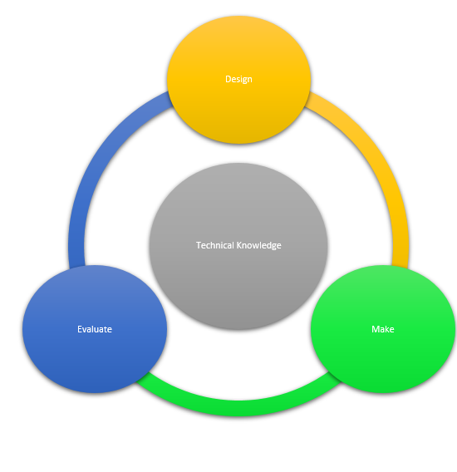
● Cooking and nutrition is given a particular focus in the National curriculum and pupils revisit this subject throughout their time at Landscove C of E Primary School, along with:
● Mechanisms/ Mechanical systems
● Structures
● Textiles
● Electrical systems (KS2 only)
● Digital world (KS2 only)

Through our DT scheme, pupils respond to design briefs and scenarios that require consideration of the needs of others, developing their skills in the six key areas. Each of our key areas follows the design process (design, make and evaluate) and has a particular theme and focus from the technical knowledge or cooking and nutrition section of the curriculum. Our DT curriculum is a spiral curriculum, with key areas revisited again and again with increasing complexity, allowing pupils to revisit and build on their previous learning. Lessons incorporate a range of teaching strategies from independent tasks, paired and group work including practical hands-on, computer-based and inventive tasks. This variety means that lessons inspire and engage those pupils requiring a variety of learning styles. Differentiated guidance is available for every lesson to ensure that lessons can be accessed by all pupils and opportunities to stretch pupils’ learning are available when required. Knowledge organisers for each unit support pupils in building a foundation of factual knowledge by encouraging recall of key facts and vocabulary.

The National Curriculum
Key stage 1
Through a variety of creative and practical activities, pupils should be taught the knowledge, understanding and skills needed to engage in an iterative process of designing and making. They should work in a range of relevant contexts [for example, the home and school, gardens and playgrounds, the local community, industry and the wider environment].
When designing and making, pupils should be taught to:

Design
- design purposeful, functional, appealing products for themselves and other users based on design criteria
- generate, develop, model and communicate their ideas through talking, drawing, templates, mock-ups and, where appropriate, information and communication technology
Make
- select from and use a range of tools and equipment to perform practical tasks [for example, cutting, shaping, joining and finishing]
- select from and use a wide range of materials and components, including construction materials, textiles and ingredients, according to their characteristics Evaluate
- explore and evaluate a range of existing products
evaluate their ideas and products against design criteria
Technical knowledge
- build structures, exploring how they can be made stronger, stiffer and more stable
- explore and use mechanisms [for example, levers, sliders, wheels and axles], in their products.

Key stage 2
Through a variety of creative and practical activities, pupils should be taught the knowledge, understanding and skills needed to engage in an iterative process of designing and making. They should work in a range of relevant contexts [for example, the home, school, leisure, culture, enterprise, industry and the wider environment].
When designing and making, pupils should be taught to:

Design
- use research and develop design criteria to inform the design of innovative, functional, appealing products that are fit for purpose, aimed at particular individuals or groups
- generate, develop, model and communicate their ideas through discussion, annotated sketches, cross-sectional and exploded diagrams, prototypes, pattern pieces and computer-aided design
Make
- select from and use a wider range of tools and equipment to perform practical tasks [for example, cutting, shaping, joining and finishing], accurately
- select from and use a wider range of materials and components, including construction materials, textiles and ingredients, according to their functional properties and aesthetic qualities
Evaluate
- investigate and analyse a range of existing products
- evaluate their ideas and products against their own design criteria and consider the views of others to improve their work
- understand how key events and individuals in design and technology have helped shape the world
Technical knowledge
- apply their understanding of how to strengthen, stiffen and reinforce more complex structures
- understand and use mechanical systems in their products [for example, gears, pulleys, cams, levers and linkages]
- understand and use electrical systems in their products [for example, series circuits incorporating switches, bulbs, buzzers and motors]
- apply their understanding of computing to program, monitor and control their products.

Cooking and nutrition
As part of their work with food, pupils should be taught how to cook and apply the principles of nutrition and healthy eating. Instilling a love of cooking in pupils enabling creativity. Learning how to cook is a crucial life skill that enables pupils to feed themselves and others affordably and well, now and in later life.
Pupils should be taught to:

Key stage 1
- use the basic principles of a healthy and varied diet to prepare dishes
- understand where food comes from.

Key stage 2
- understand and apply the principles of a healthy and varied diet
- prepare and cook a variety of predominantly savoury dishes using a range of cooking techniques
- understand seasonality, and know where and how a variety of ingredients are grown, reared, caught and processed.

ROLLING PROGRAMME

 | Autumn 1 | Autumn 2 | Spring 1 | Spring 2 | Summer 1 | Summer 2
EYFS |  | Junk modelling |  | Soup |  | Boats
Year A  Years  1 & 2 |  | Food Technology |  | Mechanisms |  | Structures
Year B  Years  1 & 2 |  | Structures |  | Textiles |  | Mechanisms
Year A  Years  3 & 4 |  | Electrical and Mechanical Components |  | Food Technology |  | Mechanisms, axels, pulleys, gears, levers
Year B  Years  3 & 4 |  | Structures |  | Textiles |  | Digital World
Year A  Years  5 & 6 |  | Electrical and Mechanical Components |  | Food Technology | . | Mechanisms, axels, pulleys, gears, levers
Year B  Years  5 & 6 |  | Structures |  | Textiles |  | Digital World

CPD
To deliver a highly effective and robust Design and technology curriculum a strong subject knowledge is vital for staff. Each unit of lessons in the scheme we use, includes multiple teacher videos to develop subject knowledge and support ongoing CPD to enable teachers to feel confident in delivering the full Design and technology curriculum. This ensures that the implementation of our curriculum delivers lessons of a high standard that ensure pupil progression.

Progression of Key Skills
Key skills
Please see our Kapow DT progression of skills document.
Landscove DT Skill Progression.
In order to assess impact - a guide
Children will develop:

With our Design and technology, pupils should leave school equipped with a range of skills to enable them to succeed in their secondary education and be innovative and resourceful members of society. The expected impact of following the scheme we follow is that children will:

The Design and Technology curriculum can be monitored through formative and summative assessments. The Kapow scheme aids teachers in assessment by giving them guidance and the key learning objects in which to assess each pupils learning against.

Have grown a passion for the subject.
Have an appreciation for key individuals, inventions, and events in history and of today that impact our world.

- An excellent attitude to learning and independent working.
- The ability to use time efficiently and work constructively and productively with others.
- The ability to carry out thorough research, show initiative and ask questions to develop an exceptionally detailed knowledge of users’ needs.
- The ability to act as responsible designers and makers, working ethically, using finite materials carefully and working safely.
- A thorough knowledge of which tools, equipment and materials to use to make their products.
- The ability to apply mathematical knowledge and skills accurately.
- The ability to manage risks exceptionally well to manufacture products safely and hygienically.
- Self-evaluate and reflect on learning at different stages and identify areas to improve.
- Understand and apply the principles of healthy eating, diets, and recipes, including key processes, food groups and cooking equipment.
- Meet the end of key stage expectations outlined in the National curriculum for Design and technology.
- Meet the end of key stage expectations outlined in the National curriculum for Computing.

Assessment of children's learning in Design Technology is an ongoing monitoring of children's understanding, knowledge and skills by the class teacher, throughout lessons. This assessment is then used to inform differentiation, support and challenge required by the children.

The impact of our Design and Technology Curriculum can be constantly monitored through both formative and summative assessment opportunities. Each lesson within the Kapow scheme that we follow includes guidance to support teachers in assessing pupils against the learning objectives.

