Landscove C of E Primary School Ethos Group Minutes
Date: 6th Feb 2023

In attendance | Jill Ryder, Becky Drew, Michelle Pearse, Anna Neville | Actions
Apologies | Laura McAdam (on sabbatical), Christine Pascoe, Grace Coles, Becky Honour, Rachel Baber
Approve previous minutes | Minutes approved
Matters arising from previous meeting | Michelle to approach FOLS reps to seek support for this group – welcome to our new parent reps!  Anna: to invite local community to KS1 dress rehearsal & for coffee after – this was done. Lovely responses and visits by locals.
School Ethos, SIAMS and RE | Report attached. Anna talked through our report and allowed time for questions and discussion.  Grace Coles has supported Anna to complete a book scrutiny, including looking at class SWAYS.  Discussed visitors and the impact this has on children and their ability to discuss world views – eg Humanist speaker.  Children’s collective worship survey outcomes discussed:  MP: we need to action the chn request to use benches as this illustrates that their voce is heard and actions are taken. JR/AN agreed.  BD feedback: what happens in school is relayed at home. General curiosity and sense of language being used at a parent level.  Do children repeat words or actually understand prayers like the lords prayer? We make prayer relevant and it is invitational. All staff ensure that language is unpicked and meaning is given – in order for our school community to come together in this way the children need to understand why and that is part of our teaching during collective worship.  MP feedback: proud she was that her chn understood Christing service and new the lords prayer.  Anna explained that a CW programme is in place but following the survey we would like to consider making use of Picture news to introduce an element of what is happening in the world at any given time. We would add subscription o a FOLS wish list for Sept. This was received positively.  BD reported that there is a real sense of spiritual awareness and that all are welcome and can have a view of their own – inclusive.  How are our values reflected in policies like our behaviour management? JR explained that our values are bedrock upon which everything is built. The values form the first page of our positive behaviour policy ~ see below  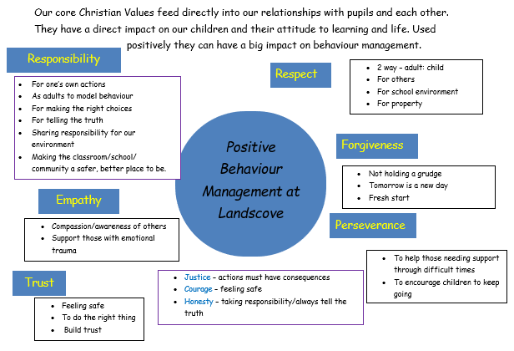  Community links  Further discussion on how we reach out beyond our school community. Our community goes beyond Landscove as we have families from various localities.  At Christmas we did reach our local village community. Lots of positive feedback.  Discussed May Day event and combining coronation and some country dancing but holding the event at school – street party feel. We could invite local community to join us.  Discussion regarding Silver Stories. This will have staffing implications. An adult needs to be available and have a back up whilst children make phone calls (safeguarding is the issue here)  Re-establish link with Redmount and establish new link with St Andrew's.  MP suggested sending video link to performances. | Questions raised – answers in green  Re-establish link with Redmount and establish new link with St Andrew's. JR and AN to discuss with staff.  Jill / Anna to let Christine know of our plans and get invitee list  Jill to advertise Messy Church for Buckfastleigh and Ashburton in newsletter
Academy Head report | Report attached  - Discussed attached report.
Parent Rep feedback | Discussion re moving our meeting time  BD: Music provision: What more could we offer on top of Music curriculum & peripatetic teaching  Song Machine (choir ) is in place and makes most of opportunities – attending SDCC music event in March  JR & AN discussed aim to have a music week next year as our Arts Week.  For art we will take part in a diocese project : Spirited art.  After school clubs: can we offer more variety? JR to put something in newsletter to see if any parents might like to run a club. | Jill to send out a grid to allow members to select times that work for them  Jill to ask Peripatetic teachers if they are interested in running a music club
Date of next meeting | Mon 27th March 3:30 in staffroom ~ subject to change after feedback!

