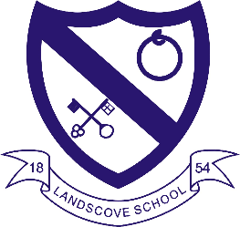
LANDSCOVE C OF E PRIMARY SCHOOL
RE & CW Lead Report for the School Ethos Group
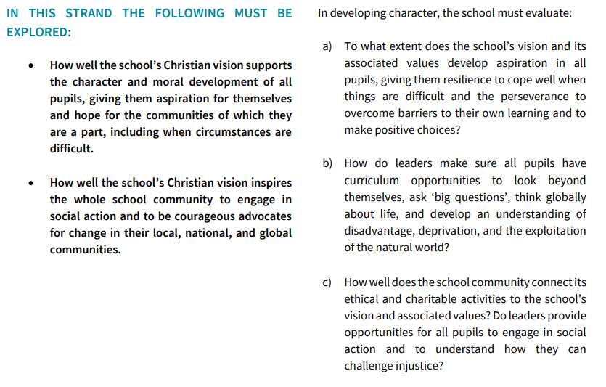
SIAMS Strand 3 – Character development: Hope, Courageous Advocacy and Aspiration
Please have questions ready relating to this strand

20.6.22 Grand Opening of Spiritual Garden.
22.6.22 Miles for Refugees - £299 raised for The British Red Cross Campaign
24.6.22 Christine Pascoe talked to the children about her job as a Marine Biologist and the impact of Plastic Pollution, consolidating and further developing previous learning.
4.7.22 Global Neighbours Bronze Award application submitted.
4.7.22 Grace and the members of the Ethos Group from Class 3 prepared beeswax wraps for sale at FOLS summer Fair.
6.7.22 Class three – Environmental Walk around Decoy Lake learning about sustainability.
8.7 .22 Class two trip to Buckfast Abbey to watch Fisherman’s Tale

Upcoming Events
Class 4 are planning on hosting a Fairtrade coffee morning.
18.7.22 AN meeting with Global Neighbours Assessor
12.9.22 Planet and People Workshop
Community Interest Company founded in 2020 as a result of the growing need to empower communities to be drivers of change in creating a healthier environment for planet and people.
https://www.planetandpeople.co.uk/

LANDSCOVE C OF E PRIMARY SCHOOL
Academy Head Report for the School Ethos Group

PUPIL NUMBERS

R 11
Y1 17
Y2 13
Y3 13
Y4 10
Y5 13
Y6 12
Total 89

CLASS ORGANISATION
- Class 1 : R (0.4 Rebecca Barons, 0.6 Jo Woods)
- Class 2: Y1 & Y2 (FT Jenny Foster)
- Class 3: Y3 & Y4 (0.5 Anna Neville, 0.5 Anne Smart)
- Class 4: Y5 & Y6 (Chloe McFadzean FT)

STAFFING UPDATES
There will be a few changes from September.
- Mrs Richardson makes a welcome return from maternity leave and will be covering PPA for classes 2 and 3 – which means she will be teaching for ½ a day a week in these classes.
- Miss Kearle also joins us again after her maternity leave. She will be working in class 1 on Tuesday & Wednesday. Which means a change in hours for Miss West who will continue to run breakfast club Monday-Thursday and will be working in Class1 on a Thursday.
- Sadly Miss M is leaving us at the end of term to take a year out and travel the world- we hope she makes many memories on this fab adventure!
- Mrs Smart & Mrs Neville will be moving to take up the reins of class 4 using their experience and expertise to ensure the best of fun and outcomes in the Landscove ‘finishing school!’
- We welcome Mr Luke Ansermoz as he joins us to be at the helm of Class 3. He comes to us from Bearnes Primary School, having worked within the Trust for the last few years. He will be attending our transition day to enable him to meet his new class.
SCHOOL IMPROVEMENT PLAN & SCHOOL SELF EVALUATION:
- Our new school improvement priorities will be:
- Key priority 1: to develop an effective approach to positive behaviour management that supports inclusion, engagement and outcomes; that is that is underpinned by our ethos and values and is built on relationships and the wellbeing of all. Relational approach – we will be gaining the knowledge about this during the year.
- Key priority 2: To ensure that the oracy approach is embedded across the school and language opportunities are planned for all subjects. To raise the profile of adventurous and technical vocabulary across the curriculum.
- Key priority 3: Feedback selected as the driver to develop Metacognition &Self-Regulated Learning:
Teacher-to-pupil feedback to be developed as a strategy to foster metacognitive talk and Self Regulated Learning in the classroom using EEF research. We will observe and audit Metacognition &Self-Regulated Learning approaches. We will ensure we continue to articulate and model own thinking to help pupils develop their metacognitive and cognitive skills
Cognition is a mental process that includes memory, attention, producing and understanding language, reasoning, learning, problem-solving and decision making. Metacognition in simplest form is thinking about thinking.
- Key priority 4: review and refine key skills documents across the curriculum – focus on DT, History, geography, and Science as starting points. Within each subject ensure check points, end points, and how assessment informs & ensures progress.
- Key priority 5: Phonics – continue to develop and embed Phonic Bug synthetic phonics programme, to ensure best practice and that by the end of KS1 all phonic sounds and application to spelling has been secured

OTHER INFORMATION – VISITORS - COURSES ETC
- A number of sporting events / adventurous activities have taken place across this half term: Fielding event for Y3/4, C4 residential, Miles for refugees, C4 canoe adventure day, C3 Decoy environmental & kayaking trip, Sports day & Mr Tanner’s community sports day to name but a few!
- Classes 1&2 have visited the Aquarium, Stover Country Park, Buckfast Abbey.
- All these events have been made possible by using both Landscove & Broadhempston mini buses. It is increasingly difficult to secure coaches as many local firms have reduced their drivers since COVID. This means they are often unable to jeopardise their school run services. It certainly has an impact on what and when we can book.
- New reception starters have visited across this half term – a tea party has been booked for 8th July to coincide with FOLS Summer Fayre. I am happy to report that we have 14 children starting with us in Class 1.
- We have / will have hosted work experience students from KEVICCs, SDCC, Ivybridge Community College & Newton Abbot College
- Year 6 Transition days have/will be taking place before the end of term
- Across this half term I have had visits from key staff from SDCC, KEVICCs, Torquay grammar schools and Churston to discuss pupils and then to meet them and have Q&A sessions
- KS2 SATS results are back – these are looking good and there are no surprises. These results will be sent home with end of year reports on 15th July

HEALTH & SAEFTY/ SAFEGUARDING/ BEHAVIOUR/C19
- Termly safeguarding summary has been completed by Jill for Trustees
- Attendance reports have also been completed for governors and monitoring has taken place this term.
Safeguarding training this half term is based on: modern slavery and what this means for our school. Some senior staff have also completed Self-harm and suicide awareness training

Anna Neville & Jill Ryder

