LANDSCOVE C OF E PRIMARY SCHOOL
RE & CW Lead Report for the School Ethos Group

18th May 2022

SCHOOL ETHOS, SIAMS & RE

Collective Worship
Values of friendship and trust. Children invited to write prayers, thoughts and reflections on petals and help our friendship flower flourish.

AN applied to St Wilfrid’s Trust for a Grant. Hoping to receive £500 for RE resources.
4.5.22: Reverend Gina visited class three to answers questions about how people of the clergy follow Jesus’ teachings.
12.5.22. AN attended RE Hub meeting.

Upcoming Events
Tuesday 15th May – Local Art student to work with year 6 on a sculpture for Spiritual Garden. 4 x Tues pm
Friday 20th May: Christian Aid Big Brekkie
Monday 20th June: Grand Opening of our Spiritual Garden. Reverend Gina will start with a blessing.

Dignity and Respect – Valuing all
How well do you feel with achieve these aims?
Do you have any questions?

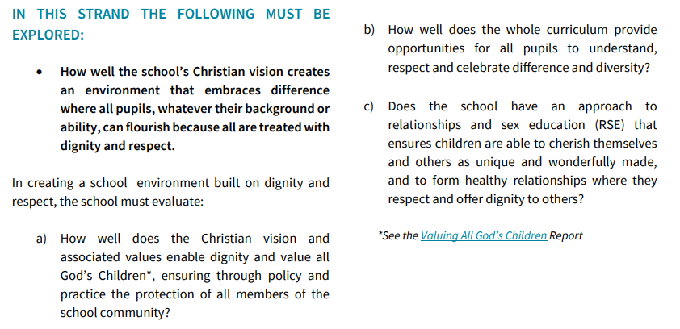

LANDSCOVE C OF E PRIMARY SCHOOL
Academy Head Report for the School Ethos Group

PUPIL NUMBERS

R 11
Y1 17
Y2 13
Y3 13
Y4 10
Y5 13
Y6 12
Total 89

CLASS ORGANISATION
- Class 1 : R (0.4 Rebecca Barons, 0.6 Jo Woods)
- Class 2: Y1 & Y2 (FT Jenny Foster)
- Class 3: Y3 & Y4 (0.5 Anna Neville, 0.5 Anne Smart)
- Class 4: Y5 & Y6 (Chloe McFadzean FT)

STAFFING UPDATES
- I’m delighted to let you know that Mrs Richardson will be returning (after maternity leave) next term to continue with PPA cover.

SCHOOL IMPROVEMENT PLAN & SCHOOL SELF EVALUATION:
- I have been beginning to sign off key areas our school improvement plan and have discussed the outcomes so far with our link governor. Our new improvement priorities are underway – although not quite finalised. I will share these with you at the next LEG meeting.

OTHER INFORMATION – VISITORS - COURSES ETC
- Subject leads have continued to work across the two schools supporting and developing their subjects and leading improvements.
- 4.5.22 Sport has continued to have a high priority with Matt Tanner organising an EYFS & KS1 multi skills event
- 4.5.22 Rev Gina visited school and worked alongside Y3&Y4 to explore how the clergy follow Jesus’ teaching
- 29.4.22 Mayday on the village green placed us back at the centre of our community & a fun time was had by all. We have been gifted £250 towards a new sound system.
- KS2 SATS have taken place 9-12th May for the majority. We had timetable variations which meant completion was 13th at the end of the morning. Children worked well in a clam and mature manner – couldn’t ask for anything more! Miss M ensured the children made the best use of the field, forest school area and a picnic to give the children some well-deserved downtime.

HEALTH & SAEFTY/ SAFEGUARDING/ BEHAVIOUR/C19
- Amanda & I completed a H&S review- The Blue Risk Management Programme has been developed by Department for Education (DfE) . At the inspection of our school a number of risk management aspects were investigated, and ratings given. We have no red issues to report on!

Safeguarding training this half term is based on:
- Contextual safeguarding, KSCIE revisit and quizzes to revisit prior updates.

Anna Neville & Jill Ryder

