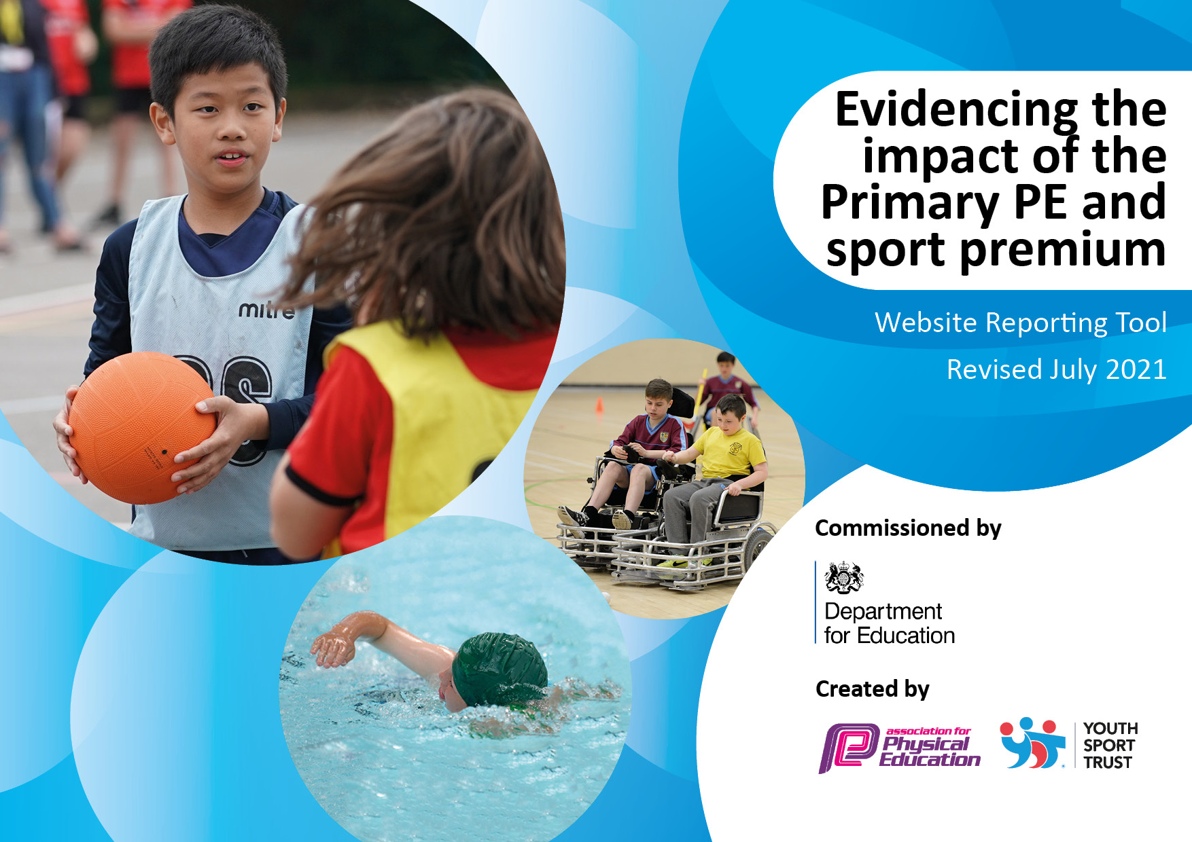
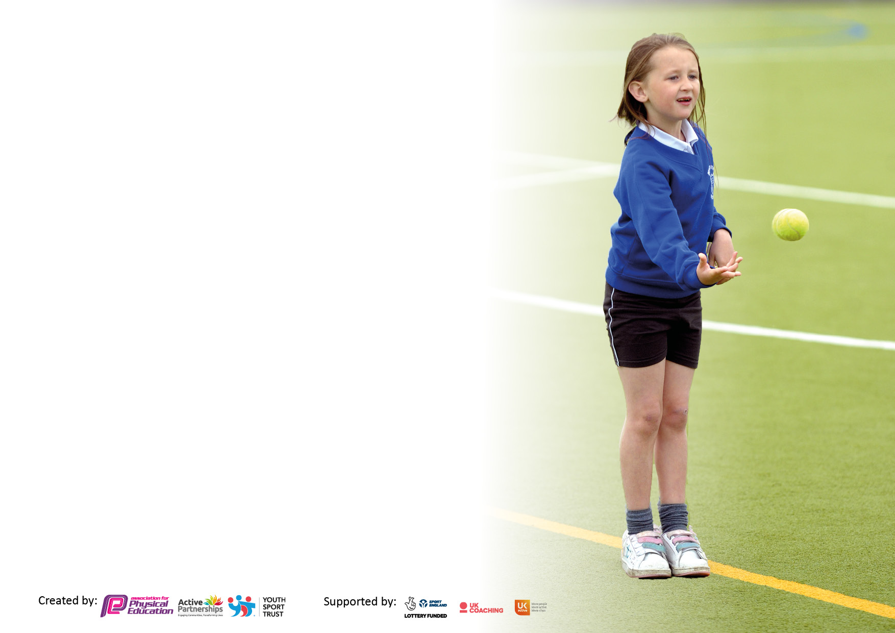

It is important that your grant is used effectively and based on school need. The Education Inspection Framework makes clear there will be a focus on ‘whether leaders and those responsible for governors all understand their respective roles and perform these in a way that enhances the effectiveness of the school’.

Under the Quality of Education Ofsted inspectors consider:
Intent - Curriculum design, coverage and appropriateness
Implementation - Curriculum delivery, Teaching (pedagogy) and Assessment
Impact - Attainment and progress

To assist schools with common transferable language this template has been developed to utilise the same three headings which should make your plans easily transferable between working documents.

Schools must use the funding to make additional and sustainable improvements to the quality of Physical Education, School Sport and Physical Activity (PESSPA) they offer. This means that you should use the Primary PE and sport premium to:

- Develop or add to the PESSPA activities that your school already offer
- Build capacity and capability within the school to ensure that improvements made now will benefit pupils joining the school in future years
- The Primary PE and sport premium should not be used to fund capital spend projects; the school’s budget should fund these.

Pleasevisitgov.ukfortherevisedDfEguidanceincludingthe5keyindicatorsacrosswhichschoolsshoulddemonstrate animprovement.Thisdocumentwillhelpyoutoreviewyourprovisionandtoreportyourspend.DfEencouragesschools to use this template as an effective way of meeting the reporting requirements of the Primary PE and sport premium.

We recommend you start by reflecting on the impact of current provision and reviewing the previous spend.

Schools are required to publish details of how they spend this funding, including any under-spend from 2019/2020, as well as on the impact it has on pupils’ PE and sport participation and attainment. All funding must be spent by 31st July 2022.

We recommend regularly updating the table and publishing it on your website throughout the year. This evidences your ongoing self-evaluation of how you are using the funding to secure maximum, sustainable impact. Final copy must be posted on your website by the end of the academic year and no later than the 31st July 2021. To see an example of how to complete the table please click HERE.
Created by: Supported by:

Details with regard to funding
Please complete the table below.

Total amount carried over from 2019/20 | £2000
Total amount allocated for 2020/21 | £18,720
How much (if any) do you intend to carry over from this total fund into 2021/22? | £0
Total amount allocated for 2021/22 | £16,720
Total amount of funding for 2021/22. To be spent and reported on by 31st July 2022. | £16,720
Swimming Data
Please report on your Swimming Data below.

Meeting national curriculum requirements for swimming and water safety.

N.B. Complete this section to your best ability. For example you might have practised safe self-rescue techniques on dry land which you can then transfer to the pool when school swimming restarts.
Due to exceptional circumstances priority should be given to ensuring that pupils can perform safe self rescue even if they do not fully meet the first two requirements of the NC programme of study
What percentage of your current Year 6 cohort swim competently, confidently and proficiently over a distance of at least 25 metres?  N.B. Even though your pupils may swim in another year please report on their attainment on leaving primary school at the end of the summer term 2021.  Please see note above | 50%
What percentage of your current Year 6 cohort use a range of strokes effectively [for example, front crawl, backstroke and breaststroke]?  Please see note above | 50%
What percentage of your current Year 6 cohort perform safe self-rescue in different water-based situations? | 69%
Schools can choose to use the Primary PE and sport premium to provide additional provision for swimming but this must be for activity over and above the national curriculum requirements. Have you used it in this way? | No

Action Plan and Budget Tracking
Capture your intended annual spend against the 5 key indicators. Clarify the success criteria and evidence of impact that you intend to measure to evaluate for pupils today and for the future.

Academic Year: 2021-22 | Total fund allocated: 16,720 | Date Updated: 10/07/2022
Key indicator 1: The engagement of all pupils in regular physical activity – Chief Medical Officers guidelines recommend that primary school pupils undertake at least 30 minutes of physical activity a day in school |  |  |  | Percentage of total allocation:
 |  |  |  | 10%
Intent | Implementation |  | Impact
Your school focus should be clear what you want the pupils to know and be able to do and about  what they need to learn and to  consolidate through practice: | Make sure your actions to achieve are linked to your intentions: | Funding allocated: | Evidence of impact: what do pupils now know and what can they now do? What has changed?: | Sustainability and suggested next steps:
Increase daily physical activity by engaging all students in daily active playtimes and during the school day.  Increase PA through extracurricular opportunities for KS1 | Specialist equipment has been purchased so students of all ages have access to a range of different physical activities during these times.  We have increased the clubs available to students in KS1. These have been led by external providers as well as class teachers. This year clubs have been:  - Football club  - Handball club  - Gymnastics club  - Multi-sports club  - Frisbee club | £1600  £0 parent funded | We have seen a marked improvement in the number of students who are physically active during the school day. The more unique sports have been really popular in engaging those who in the past have been disengaged in sport and physical activity.  The number of students in KS1 actively participating in clubs has increased. We have also seen students from reception signing up to take part. | Equipment owned by the school so can be used next year and beyond. Lunchtime programme is planned to give greater opportunity for students to be active.  Club lists in place for next year. Teachers deliver clubs on rotation to ensure these are sustainable.  External providers set up for next year.

Key indicator 2: The profile of PESSPA being raised across the school as a tool for whole school improvement |  |  |  | Percentage of total allocation:
 |  |  |  | 18%
Intent | Implementation |  | Impact
Your school focus should be clear what you want the pupils to know and be able to do and about  what they need to learn and to  consolidate through practice: | Make sure your actions to achieve are linked to your intentions: | Funding allocated: | Evidence of impact: what do pupils now know and what can they now do? What has changed?: | Sustainability and suggested next steps:
Specialist PE staff to raise profile of PE and school sport to drive forward improvement in the subject and whole school community.  Use PE as a driver for improvements in student learning.  Increase students excitement of PE lessons through specialist resources. | The school has employed a specialist PE teacher.  New PE curriculum and planning rolled out to give staff the tools to improve the quality of teaching and learning through sport and physical activity.  Purchase of specific PE equipment for each activity included in the PE curriculum | See KS1  £0 – designed by trust PE team.  £3100 | All students have a high-quality PE lesson from a specialist teacher. Impact of PE specialist has meant that PE is a valuable part of the curriculum and there is greater enthusiasm for the subject .  Staff have access to regular CPD to improve their delivery of quality PE.  Higher quality learning is now taking place in PE. Link made to other curriculum subjects also used within PE lessons to develop wider student understanding.  Improved quality of PE lessons and amount of sport/physical activity taking place across the school.  Improved profile of PE lessons due to the access to specialist equipment. | E teacher employed on a permanent contract to continue developing staff competence.  PE specialist contract renewed to ensure this benefit is sustained.  Equipment stored effectively in school and will be used in future years. Staff trained on how to use these effectively by PE teacher.

Key indicator 3: Increased confidence, knowledge and skills of all staff in teaching PE and sport |  |  |  | Percentage of total allocation:
 |  |  |  | 54%
Intent | Implementation |  | Impact
Your school focus should be clear | Make sure your actions to | Funding | Evidence of impact: what do | Sustainability and suggested
what you want the pupils to know | achieve are linked to your | allocated: | pupils now know and what | next steps:
and be able to do and about | intentions: |  | can they now do? What has
what they need to learn and to |  |  | changed?:
consolidate through practice:
Regular professional development for all teaching staff, promoting higher quality teaching of PE.  Arrange for specialists to deliver sports to develop staff subject knowledge. | Employed school PE teacher to deliver regular training for staff.  Class teachers work with PE specialist to assess students and have regular feedback about their own delivery of PE.  Community sports day arranged with providers delivering fencing, martial arts and yoga. Staff all in attendance to develop subject knowledge. | £9025  See KI4 | All staff have received regular CPD from PE specialist. Teaching staff are now more confident delivering the wide variety of activities included within the PE curriculum.  Staff confidence increased. | PE teacher employed on a permanent contract to continue developing staff competence.  Evidence made by PE teacher and day is planned again with alternative activities next year.

Key indicator 4: Broader experience of a range of sports and activities offered to all pupils |  |  |  | Percentage of total allocation:
 |  |  |  | 12%
Intent | Implementation |  | Impact
Your school focus should be clear | Make sure your actions to | Funding | Evidence of impact: what do | Sustainability and suggested
what you want the pupils to know | achieve are linked to your | allocated: | pupils now know and what | next steps:
and be able to do and about | intentions: |  | can they now do? What has
what they need to learn and to |  |  | changed?:
consolidate through practice:
Diverse PE curriculum offering students a range of sports and activities.  Develop leadership opportunities for students in KS2.  Use specialist providers to offer students exciting and varied activities.  Give KS2 students the opportunity to experience outdoor and adventurous activity. | Our PE curriculum is designed by specialist PE teacher. This gives students the chance to learn 12 sports and activities over a 2-year cycle.  Set up a new Sports Leaders Programme for KS2 students.  Whole-school community day planned for the start of July. Activities: Rugby with Exeter Chiefs, martial arts, yoga, football, tennis and fencing.  Canoe trip for the whole of year 5 & 6 class.  Year 3 & 4 class given a kayaking | Included in KI3 cost (£9025).  £0 – rolled from last year.  £920  £750  £300 | Students enjoy a huge variety of activities and this has developed a love for sports and PA.  KS2 students have successfully began the sports leaders programme, which has had an impact on younger students across the school. This has also given KS2 students their first step towards leadership for life as well as improving your interpersonal skills, both of which will help with transition into secondary school.  All students took part in a range of new and exciting experiences from specialist providers.  Students had a great time and have made lasting memories whilst also developing water-based skills. | Curriculum in place for next year, with continued high-quality teaching.  Yearly programme  Links made with external providers so they can offer further events like this in the future.  Continuation of funding will allow trips in the future.

Key indicator 5: Increased participation in competitive sport |  |  |  | Percentage of total allocation:
 |  |  |  | 2%
Intent | Implementation |  | Impact
Your school focus should be clear | Make sure your actions to | Funding | Evidence of impact: what do | Sustainability and suggested
what you want the pupils to know | achieve are linked to your | allocated: | pupils now know and what | next steps:
and be able to do and about | intentions: |  | can they now do? What has
what they need to learn and to |  |  | changed?:
consolidate through practice:
Offer students trust-wide competitions to every student in the school from EYFS-year 6. | Students have competed in the following events:  - KS2 tag rugby  - KS2 cross country  - EYFS & KS1 multi-skills  - Year 5 & 6 Handball  - KS2 Football  - Year 3 & 4 striking and fielding.  - KS2 tennis  - Athletics | £100 venue  £240 transport | All students have proudly represented their school at an event this year with many ks2 students taking part in lots. | Events planned next year to increase opportunities. Run by the trust PE team.

Signed off by
Head Teacher: | Jill Ryder
Date: | 26/07/22
Subject Leader: | Matt Tanner
Date: | 14/07/22
Governor:
Date:

