LANDSCOVE C OF E PRIMARY SCHOOL
RE & CW Lead Report for the School Ethos Group 22nd April 2024

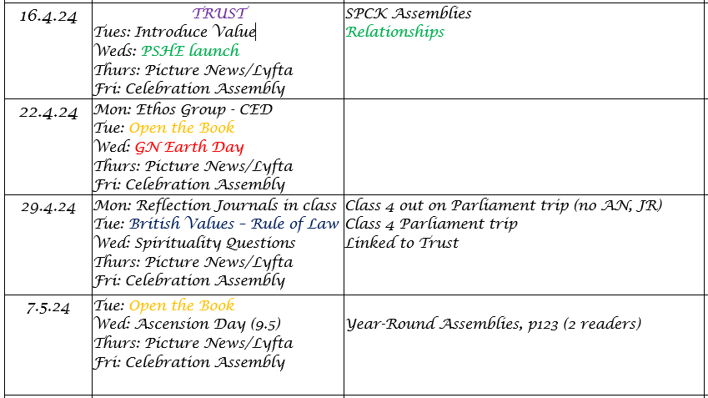
Collective Worship for the half term:
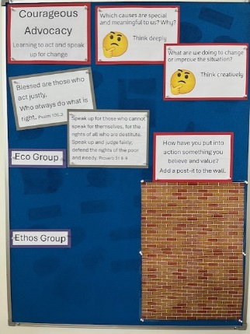
Rolling programme covers core Christian Values, key events on Christian calendar, British Values, Global Neighbours (events from Christian Aid calendar and Picture News), Child led worship.

Reflective Space
Ethos Group rota to record younger children’s prayers, thoughts and reflections is now in place.

Global Neighbours
- 15.4.24 AN led staff training.
- Reviewed SEF
- Identified points for development: roles and responsibilities of pupil voice groups, subject leads and class teachers
- 3.7.24 Arts Week linked to anti-racism. Sandhya Dave (Cultural Champion) booked to launch event.
A selection of work to be entered in Spirited Arts Competition.

LANDSCOVE C OF E PRIMARY SCHOOL
Academy Head Report for the School Ethos Group

PUPIL NUMBERS

R 7
Y1 14
Y2 16
Y3 15
Y4 15
Y5 11
Y6 7
Total 85

CLASS ORGANISATION
Class 1: R (0.4 Rebecca Barons, 0.6 Jo Woods)
Class 2: Y1 & Y2 (0.6 Jo Lunt, 0.4 Sophie Pritchard)
Class 3: Y3 & Y4 (Luke Ansermoz FT)
Class 4: Y5 & Y6 (0.5 Anna Neville, 0.5 Jas Capaldi)

Jas Capaldi covers PPA across the school

STAFFING UPDATES
We welcome Mrs Lunt to the school team.
SCHOOL IMPROVEMENT PLAN & SCHOOL SELF EVALUATION:
Staff meetings this ½ term are linked to our school improvement plan. We will be completing the following INSET:
- 15.4.24 NPD Preparing for O. Non negotiables. Impact of curriculum. GN @ Landscove PM. Karen & staff @ B PM. SEF.
- 17.4.24 Pupil Voice – individual schools. incl all awards and redefining PV groups.
- 24th April ORACY: revisit training and impact document. Expectations across curriculum previously agreed – revisit.
- 1ST May Science with Jo & DISCUSS Reports: sort format
- 8th May reviewing SEF with staff and updating for our schools Jill @ L. Karen @ B
- 15th May Writing progression – Trust & School priority. Sentence CPD.
- 22nd Mayeading revisit expectations & share good practice - impact of guided reading and use of Rethink Reading.

I have updated the ASIP & SEF (School Self Evaluation Form)over the Easter holidays, so they are ready should they be required for an Ofsted inspection.
OTHER INFORMATION – VISITORS - COURSES ETC
- We had a fairly busy half term since our last meeting.
- Parent consultations were held on 27th & 29th February.
- Class assemblies took place across the spring term.
- All staff have attended regular bug club phonics training & Reading for pleasure training – these tend to be held on a Thursday at 4pm.
- 5/3, 7/3 & 21/3 Jill completed NPQLBC trainer training. On 22nd March Jill delivered the first 2 units of NPQ to applicants from across the Trust
- Mothering Friday took place 8th March – this was a lovely service for all those special ladies in our lives.
- Across the term Jo Woods and Becky Barons attended their NPQ clinics which supports them in gaining their qualification later in this year.
- Forest School has taken place for classes 2 and 4 and our new providers are working with Mr A to find a suitable date to pay us back for the missed session.
- 22/3/24Jas Capaldi attended an Outdoor education conference with a view to looking at learning beyond the classroom.
- 26/3Easter Service & Easter in a day took place – always delightful in school.
- Finally during the Easter Holidays some wonderful parents cleared our car park, cut back trees and filled potholes – what fabulous supporters of our school!

HEALTH & SAEFTY/ SAFEGUARDING/ BEHAVIOUR
- Tree inspections have taken place.
- Fire drills as per schedule have taken place. We have not had any other H&S training during the previous half term.
- Safeguarding has centred on Filtering and monitoring checks and the AIMS project.
- Anna & Becky continue to attend the relational approach best practice group.

Anna Neville & Jill Ryder

