Landscove C of E Primary:
Number & Calculation policy: Years 1&2

Rationale
It is our intent, based on school research and our study as part of the Jurassic Maths Hub, to enable KS1 children to develop the core ideas that underpin all calculation. They begin by connecting calculation with counting on and counting back, but they should learn that understanding wholes and parts will enable them to calculate efficiently and accurately, and with greater flexibility. They learn how to use an understanding of 10s and 1s to develop their calculation strategies, especially in addition and subtraction. Children develop an awareness of equal groups and link this with counting in equal steps, starting with 2s, 5s and 10s. In Year 2, they learn to connect the language of equal groups with the mathematical symbols for multiplication and division.
They learn how multiplication and division can be related to repeated addition and repeated subtraction.
Staff will begin units of work with an elicitation task. These tasks will include 3 questions; fluency, reasoning and problem solving being at the heart of these tasks. These tasks will provide staff with a clear picture of children’s knowledge and skills and then allow staff to meet need and extend children’s learning from their individual starting points. They will be used again at the end of a unit of work, enabling staff to see a clear picture of progress and mastery of given areas.

Threaded through all learning across the school we use CAPED to enable children to demonstrate their mastery of mathematics:
C: check it
A: another way
P: prove it
E: explain
D: draw
Age and stage appropriate language and modelling will be found in all classes linked to CAPED
Key Vocabulary:
whole, part, ones, ten, tens, number bond, add, addition, plus, total, altogether, subtract, subtraction, find the difference, take away, minus, less, more, group, share, equal, equals, is equal to, groups, equal groups, times, multiply, multiplied by, divide, share, shared equally, times-table

Years 1&2
 | Concrete | Pictorial | Abstract
Place value | By Y2 children will be taught:
Understanding 10s and 1s | Understanding teen numbers as a complete 10 and some more  Complete a group of 10 objects and count more.  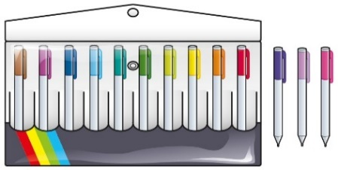  13 is 10 and 3 more. | Understanding teen numbers as a complete 10 and some more  Use a ten frame to support understanding of a complete 10 for teen numbers.  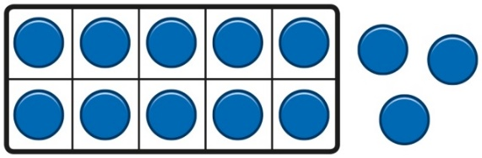  13 is 10 and 3 more. | Understanding teen numbers as a complete 10 and some more.  1 ten and 3 ones equal 13.  10 + 3 = 13
Understanding 10s and 1s | Group objects into 10s and 1s.  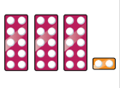  Bead strings to understand  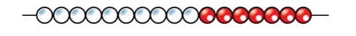 | Understand 10s and 1s equipment, and link with visual representations on ten frames.  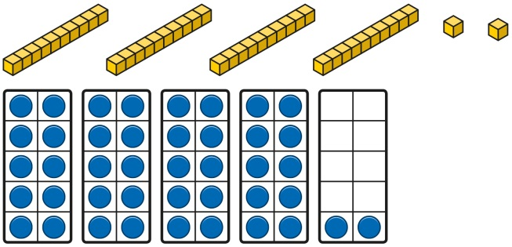 | Represent numbers on a place value grid, using equipment or numerals.  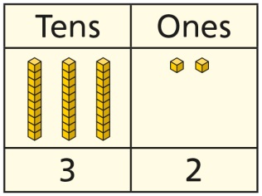  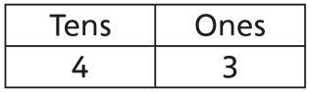
Adding 10s | Use known bonds and unitising to add 10s.  I know that 4 + 3 = 7.  So, I know that 4 tens add 3 tens is 7 tens. | Use known bonds and unitising to add 10s.  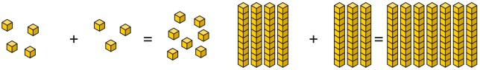  I know that 4 + 3 = 7.  So, I know that 4 tens add 3 tens is 7 tens. | Use known bonds and unitising to add 10s.  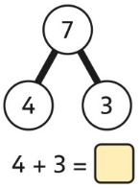 4 + 3 = 7  4 tens + 3 tens = 7 tens 40 + 30 = 70
Addition | All children will be taught:
 | Concrete | Pictorial | Abstract
Counting and adding more | Children add one more person or object to a group to find one more.  Language: the number after, one more than  Use of number line and dice | Children add one more cube or counter to a group to represent one more.  Numicon supports this area.  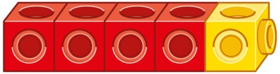  One more than 4 is 5. | Use a number line to understand how to link counting on with finding one more.  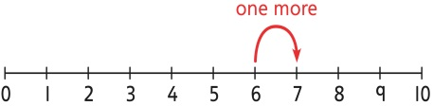  One more than 6 is 7.  7 is one more than 6.  Learn to link counting on with adding more than one.  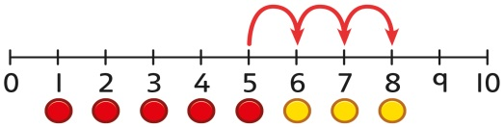  5 + 3 = 8
Understanding part-part-whole relationship | Sort people and objects into parts and understand the relationship with the whole.  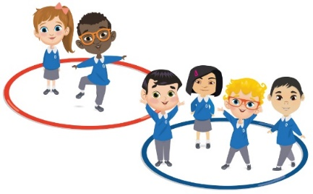  The parts are 2 and 4. The whole is 6. | Children draw to represent the parts and understand the relationship with the whole.  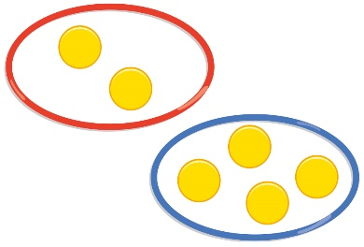  The parts are 1 and 5. The whole is 6. | Use a part-whole model to represent the numbers.  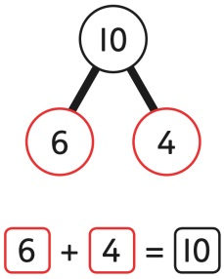  6 + 4 = 10
Knowing and finding number bonds within 10 | Break apart a group and put back together to find and form number bonds.  7+3 = 10  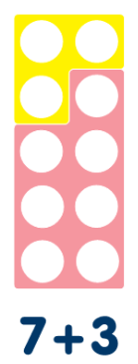 | Use five and ten frames to represent key number bonds.  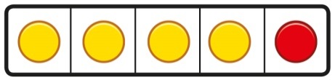  5 = 4 + 1 | Use a part-whole model alongside other representations to find number bonds. Make sure to include examples where one of the parts is zero.  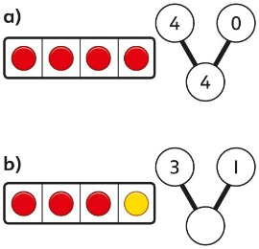  4 + 0 = 4  3 + 1 = 4
Adding by counting on | Children use knowledge of counting to 20 to find a total by counting on using people or objects.  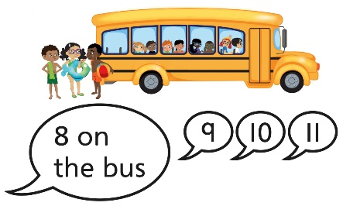 | Children use counters to support and represent their counting on strategy.  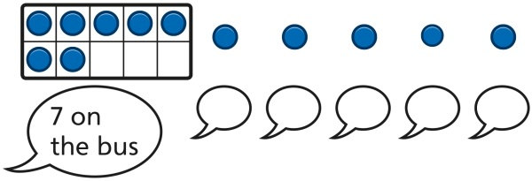 | Children use number lines or number tracks to support their counting on strategy.  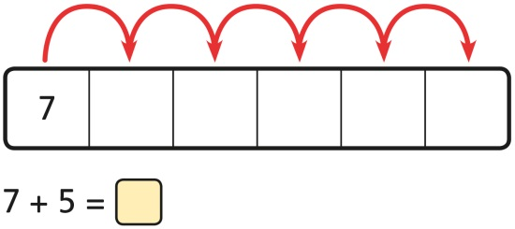
Adding the 1s | Children use bead strings to recognise how to add the 1s to find the total efficiently.  2 + 3 = 5  12 + 3 = 15 | calculations using ten frames to add a teen and 1s.  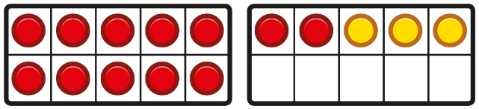  2 + 3 = 5  12 + 3 = 15 | Children recognise that a teen is made from a 10 and some 1s and use their knowledge of addition within 10 to work efficiently.  3 + 5 = 8  So, 13 + 5 = 18
Bridging the 10 using number bonds | Children use a bead string to complete a 10 and understand how this relates to the addition.  7 add 3 makes 10.  So, 7 add 5 is 10 and 2 more. | Children use counters to complete a ten frame and understand how they can add using knowledge of number bonds to 10.  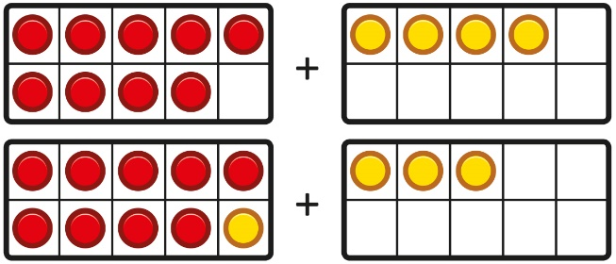  . | Use a number line to support the calculation.  9 + 4 = 13
Adding a  1-digit number to a 2-digit number not bridging a 10 | Add the 1s to find the total. Use known bonds within 10.  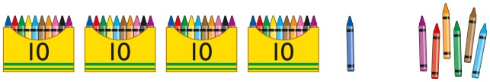  41 is 4 tens and 1 one.  41 add 6 ones is 4 tens and 7 ones.  This can also be done in a place value grid.  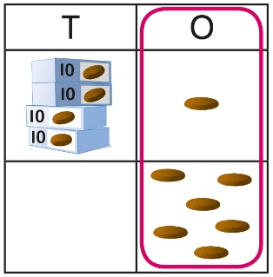 | Add the 1s.  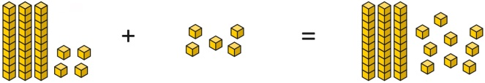  34 is 3 tens and 4 ones.  4 ones and 5 ones are 9 ones.  The total is 3 tens and 9 ones.  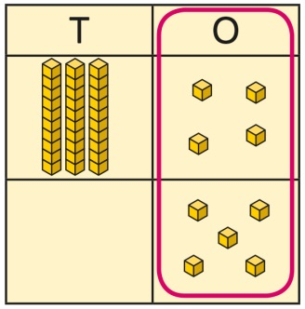 | Add the 1s.  Understand the link between counting on and using known number facts. Children should be encouraged to use known number bonds to improve efficiency and accuracy.  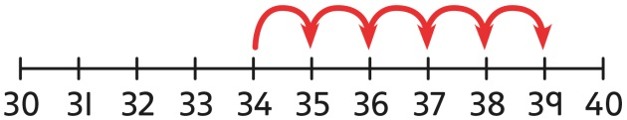  This can be represented horizontally or vertically.  34 + 5 = 39  or  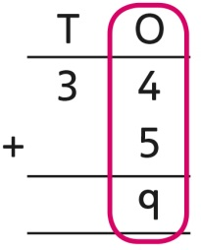
Adding a  1-digit number to a 2-digit number bridging 10 | Complete a 10 using number bonds.  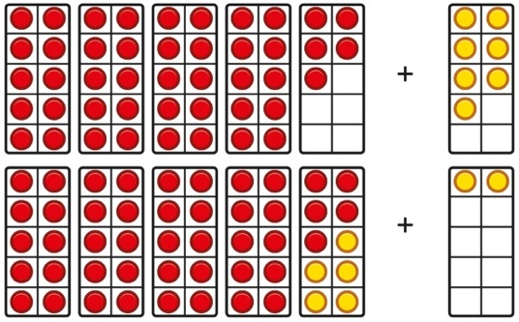 |  | Complete a 10 using number bonds.  7 = 5 + 2  45 + 5 + 2 = 52
Adding a  1-digit number to a 2-digit number using exchange | Exchange 10 ones for 1 ten.  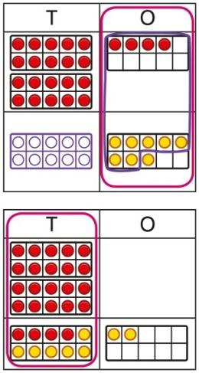 |  | Exchange 10 ones for 1 ten.  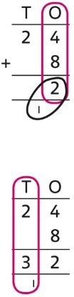
Adding a multiple of 10 to a 2-digit number | Add the 10s and then recombine.  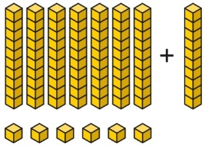  66 is 6 tens and 6 ones.  66 + 10 = 76 |  | Add the 10s and then recombine.  37 + 20 = ?  30 + 20 = 50  50 + 7 = 57  37 + 20 = 57
Adding a multiple of 10 to a 2-digit number using columns | Add the 10s using base 10 and a place value grid to support.  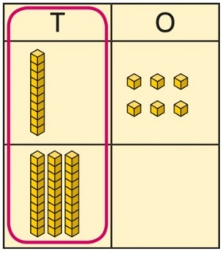  16 is 1 ten and 6 ones.  30 is 3 tens.  There are 4 tens and 6 ones in total. |  | Add the 10s represented vertically. Children must understand how the method relates to unitising of 10s and place value.  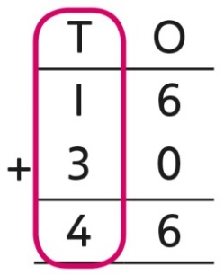  1 + 3 = 4  1 ten + 3 tens = 4 tens  16 + 30 = 46
Adding two  2-digit numbers | Add the 10s and 1s separately.  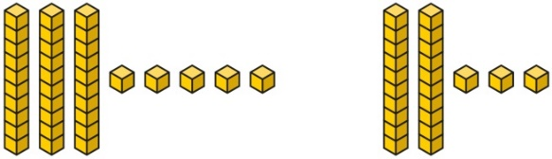  5 + 3 = 8  There are 8 ones in total.  3 + 2 = 5 (3 tens + 2 tens)  There are 5 tens in total.  35 + 23 = 58 | Add the 10s and 1s separately. Use a  part-whole model to support.  Use place value achart and base 10 to support  11 = 10 + 1  32 + 10 = 42  42 + 1 = 43  32 + 11 = 43 | Add the 10s and the 1s separately, bridging 10s where required. A number line can support the calculations.  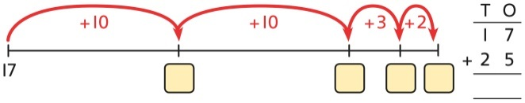  17 + 25
Adding two  2-digit numbers using a place value grid | Add the 1s. Then add the 10s.  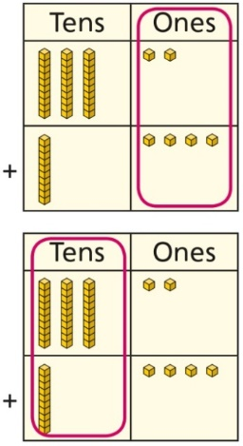 |  | Add the 1s. Then add the 10s.  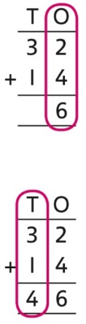
Subtraction | All children will be taught:
 | Concrete | Pictorial | Abstract
Counting back and taking away | Children arrange objects and remove to find how many are left.  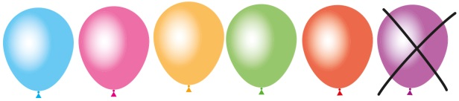  1 less than 6 is 5.  6 subtract 1 is 5. | Children draw and cross out or use counters to represent objects from a problem.  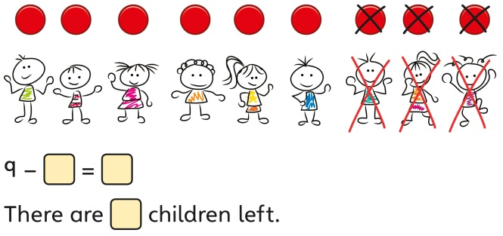 | Children count back to take away and use a number line or number track to support the method.  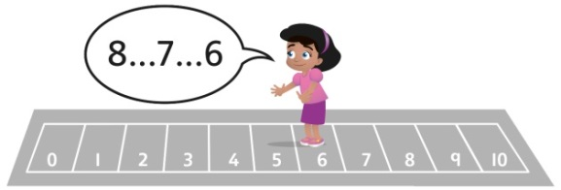  9 − 3 = 6
Finding a missing part, given a whole and a part | Children separate a whole into parts and understand how one part can be found by subtraction.  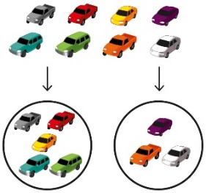8 − 5 = ? | Children represent a whole and a part and understand how to find the missing part by subtraction.  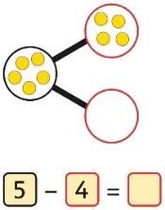 | Children use a part-whole model to support the subtraction to find a missing part.  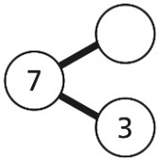  7 − 3 = ?  Children develop an understanding of the relationship between addition and subtraction facts in a part-whole model.  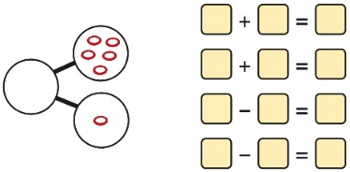  If I know this what else do I know?
Finding the difference | Arrange two groups so that the difference between the groups can be worked out.  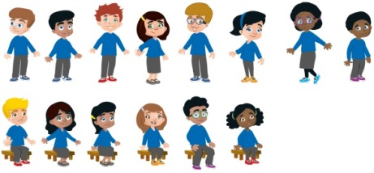  8 is 2 more than 6.  6 is 2 less than 8.  The difference between 8 and 6 is 2. | Represent objects using sketches or counters to support finding the difference.  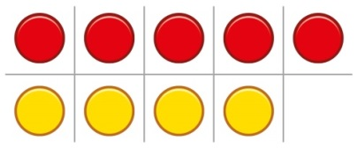  5 − 4 = 1  The difference between 5 and 4 is 1. | Children understand ‘find the difference’ as subtraction.  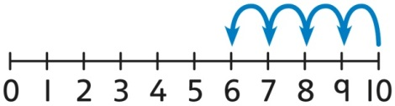  10 − 4 = 6  The difference between 10 and 6 is 4.
Subtraction within 20 | Understand when and how to subtract 1s efficiently.  Use a bead string to subtract 1s efficiently.  5 − 3 = 2  15 − 3 = 12 | Understand when and how to subtract 1s efficiently.  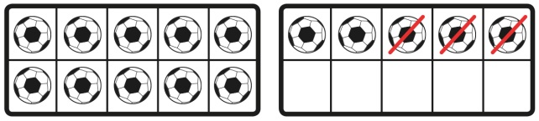  5 − 3 = 2  15 − 3 = 12 | Understand how to use knowledge of bonds within 10 to subtract efficiently.  5 − 3 = 2  15 − 3 = 12
Subtracting 10s and 1s | For example: 18 − 12  Subtract 12 by first subtracting the 10, then the remaining 2.  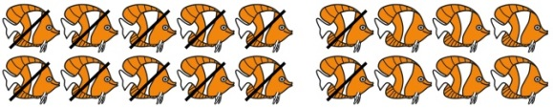  First subtract the 10, then take away 2. | For example: 18 − 12  Use ten frames to represent the efficient method of subtracting 12.  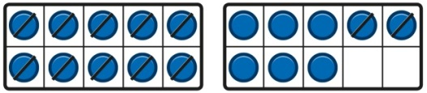  First subtract the 10, then subtract 2. | Use a part-whole model to support the calculation.  19 − 14  19 − 10 = 9  9 − 4 = 5  So, 19 − 14 = 5
Subtraction bridging 10 using number bonds | For example: 12 − 7  Arrange objects into a 10 and some 1s, then decide on how to split the 7 into parts.  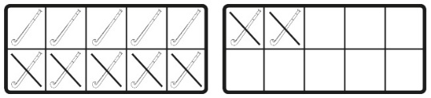  7 is 2 and 5, so I take away the 2 and  then the 5. | Represent the use of bonds using ten frames.  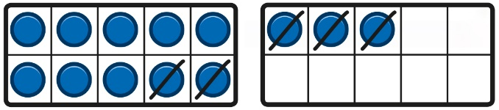  For 13 – 5, I take away 3 to make 10, then take away 2 to make 8. | Use a number line and a part-whole model to support the method.  13 − 5
Subtracting multiples of 10 | Use known number bonds and unitising to subtract multiples of 10.  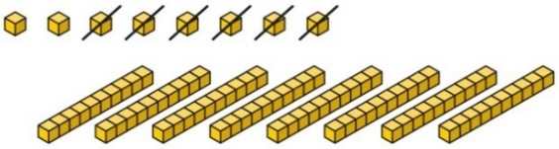  8 subtract 6 is 2.  So, 8 tens subtract 6 tens is 2 tens. | Use known number bonds and unitising to subtract multiples of 10.  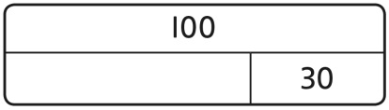  10 − 3 = 7  So, 10 tens subtract 3 tens is 7 tens. | Use known number bonds and unitising to subtract multiples of 10.  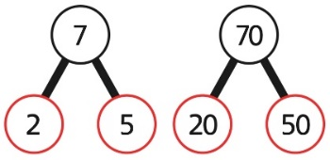  If I know that 7-5=2 then I know that 70-50=20
Subtracting a single-digit number | Subtract the 1s. This may be done in or out of a place value grid.  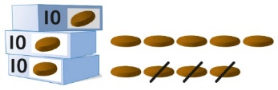  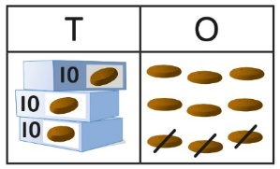 39-3= 36 | Subtract the 1s. This may be done in or out of a place value grid.  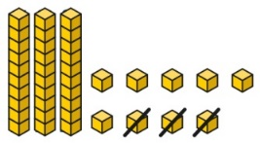  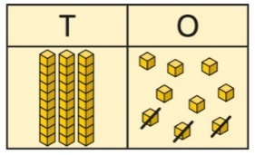 | Subtract the 1s. Understand the link between counting back and subtracting the 1s using known bonds.  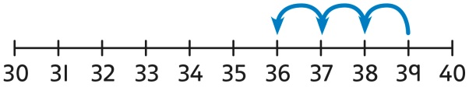  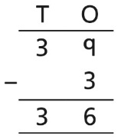 9 − 3 = 6  39 − 3 = 36
Subtracting a single-digit number bridging 10 | Bridge 10 by using known bonds.  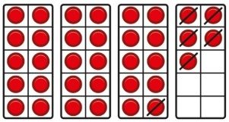  35 − 6  I took away 5 counters, then 1 more. | Bridge 10 by using known bonds.  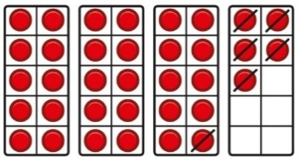  35 − 6  First, I will subtract 5, then 1. | Bridge 10 by using known bonds.  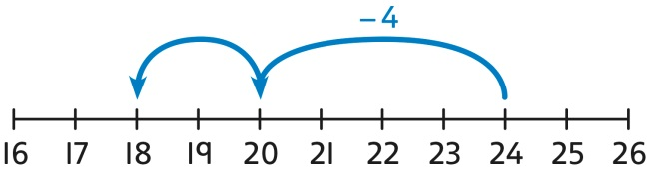  24 − 6 = ?  24 − 4 − 2 = ?
Subtracting a  2-digit number | Subtract by taking away.  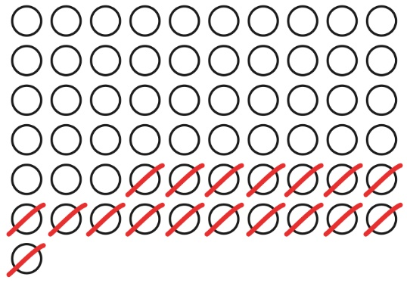  61 − 18  I took away 1 ten and 8 ones. | Subtract the 10s and the 1s.  This can be represented on a 100 square.  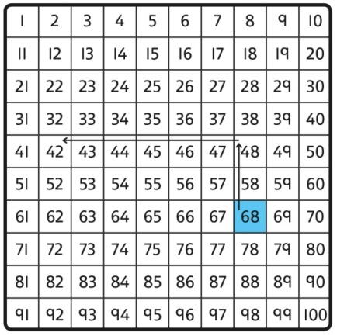  68-26 | Subtract the 10s and the 1s.  This can be represented on a number line.  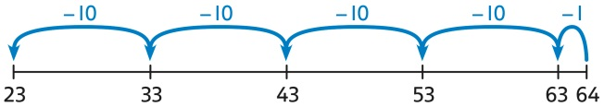  64 − 41 = ?  64 − 1 = 63  63 − 40 = 23  64 − 41 = 23  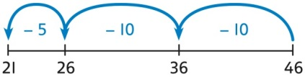  46 − 20 = 26  26 − 5 = 21  46 − 25 = 21
Subtracting a  2-digit number using place value and columns | Subtract the 1s. Then subtract the 10s. This may be done in or out of a place value grid.  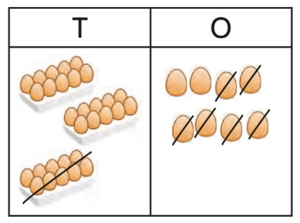  38 − 16 = 22 | Subtract the 1s. Then subtract the 10s.  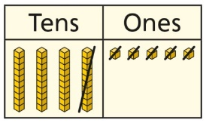 | Using column subtraction, subtract the 1s. Then subtract the 10s.  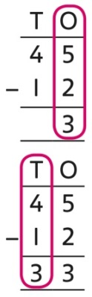
Multiplication | All children will be taught
 | Concrete | Pictorial | Abstract
Recognising and making equal groups | Children arrange objects in equal and unequal groups and understand how to recognise whether they are equal.  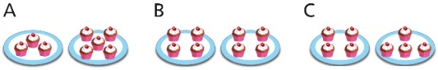 | Children draw and represent equal and unequal groups.  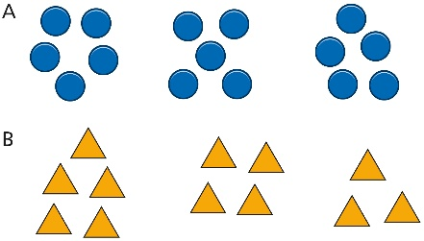 | Three equal groups of 4.  Four equal groups of 3.
Equal groups and repeated addition  Finding the total of equal groups by counting in 2s, 5s and 10s | Recognise equal groups and write as repeated addition and as multiplication.  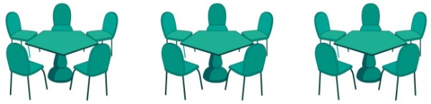  3 groups of 5 chairs  15 chairs altogether | Recognise equal groups using standard objects such as counters and write as repeated addition and multiplication.  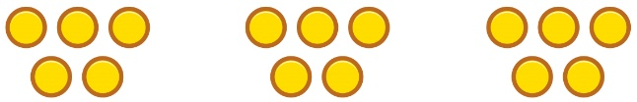  3 groups of 5  15 in total Counting in 2s, 5s and 10s | Use a number line and write as repeated addition and as multiplication.  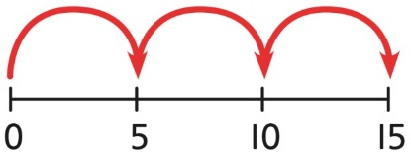  5 + 5 + 5 = 15  3 × 5 = 15
Using arrays to represent multiplication and support understanding | Understand the relationship between arrays, multiplication and repeated addition.  4 groups of 5 | Understand the relationship between arrays, multiplication and repeated addition.  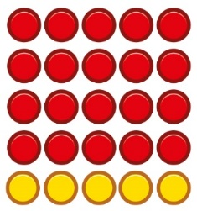  4 groups of 5 … 5 groups of 5 | Understand the relationship between arrays, multiplication and repeated addition.  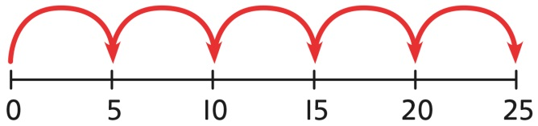  5 × 5 = 25
Understanding commutativity | Use arrays to visualise commutativity.  I can see 6 groups of 3.  I can see 3 groups of 6. | Form arrays using counters to visualise commutativity. Rotate the array to show that orientation does not change the multiplication.  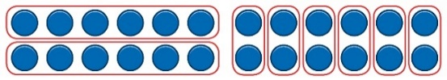  This is 2 groups of 6 and also 6 groups of 2. | Use arrays to visualise commutativity.  4 + 4 + 4 + 4 + 4 = 20  5 + 5 + 5 + 5 = 20  4 × 5 = 20 and 5 × 4 = 20
Learning ×2, ×5 and ×10 table facts | Develop an understanding of how to unitise groups of 2, 5 and 10 and learn corresponding times-table facts.  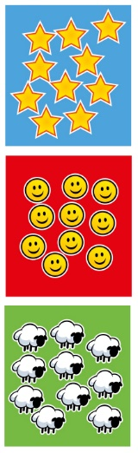  3 groups of 10 … 10, 20, 30  3 × 10 = 30 | Understand how to relate counting in unitised groups and repeated addition with knowing key times-table facts.  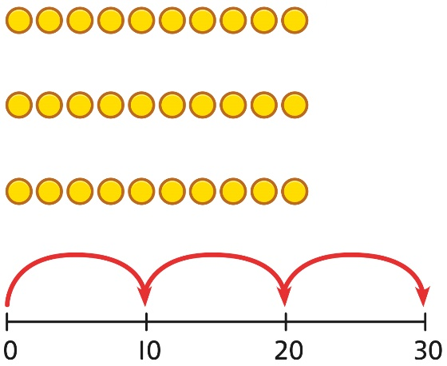  10 + 10 + 10 = 30  3 × 10 = 30 | Understand how the times-tables increase and contain patterns.  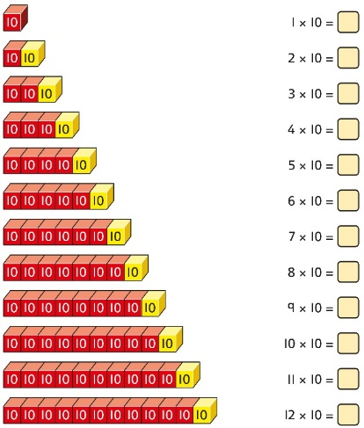  5 × 10 = 50  6 × 10 = 60
Division | All children will be taught
 | Concrete | Concrete | Concrete
Sharing | Share a set of objects into equal parts and work out how many are in each part.  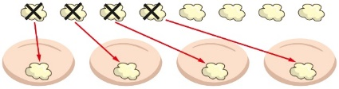 | Sketch or draw to represent sharing into equal parts/groups.  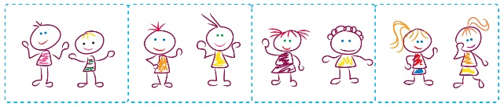 | 10 shared into 2 equal groups gives 5 in each group.
Sharing &  Grouping equally | Start with a whole and share into equal parts, one at a time.  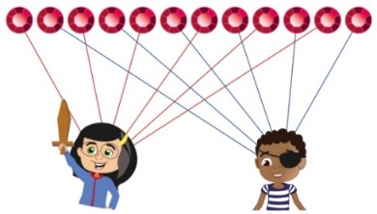  12 shared equally between 2.  They get 6 each. | Represent the objects shared into equal parts using a bar model.  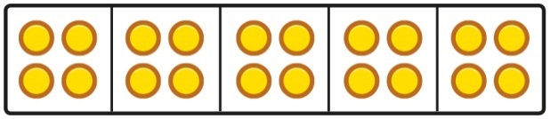  20 shared into 5 equal parts.  There are 4 in each part. | Use a bar model to support understanding of the division.  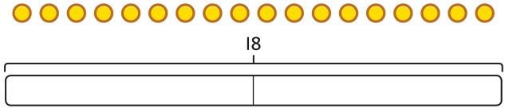  18 ÷ 2 = 9
 | Understand how to make equal groups from a whole.  8 divided into 4 equal groups.  There are 2 in each group. | Understand the relationship between grouping and the division statements.  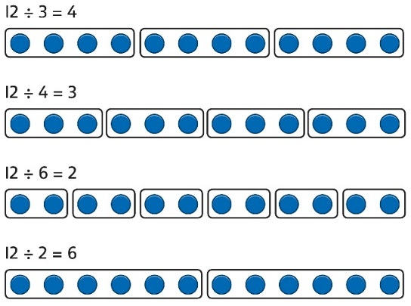 | Understand how to relate division by grouping to repeated subtraction.  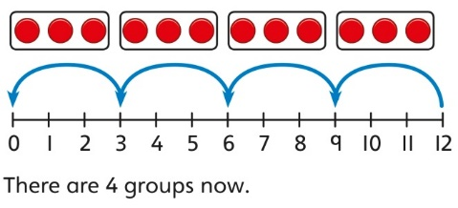  12 divided into groups of 3.  12 ÷ 3 = 4  There are 4 groups.
Using known times-tables to solve divisions | Understand the relationship between multiplication facts and division.  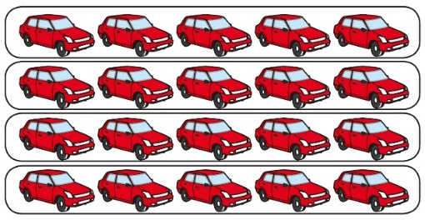  4 groups of 5 cars is 20 cars in total.  20 divided by 4 is 5. | Link equal grouping with repeated subtraction and known times-table facts to support division.  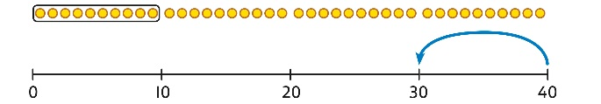  40 divided by 4 is 10.  Use a bar model to support understanding of the link between times-table knowledge and division.  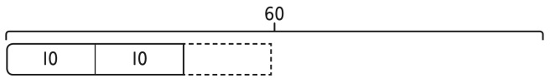 | Relate times-table knowledge directly to division.  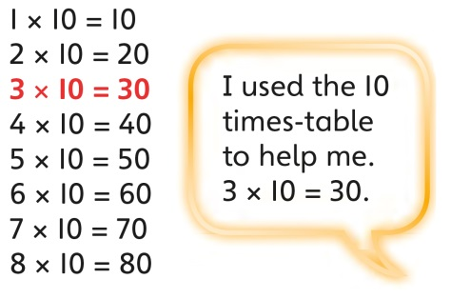  I know that 3 groups of 10 makes 30, so I know that 30 divided by 10 is 3.  3 × 10 = 30 so 30 ÷ 10 = 3

