LANDSCOVE C OF E PRIMARY SCHOOL
RE & CW Lead Report for the School Ethos Group 6th Feb 2023

13.12.23 Grace Coles joined AN for RE book scrutiny – general feedback regarding monitoring in place
11.1.23 Reverend Gina Visited Class 3
30.1.23 AN conducted a CW survey with Children’s Ethos Group – results to be shared
8.2.23 Humanist Speaker visiting Class 4

Collective Worship
This term we have covered the values of Perseverance (core) and Hope.
The children’s ‘leaves of hope’ evidence the impact of prior learning (plastic pollution, climate change) as well as a deep respect for each other and God’s world. They feel empowered to contribute to a brighter future.
In addition, the children had an opportunity to reflect on the significance of Epiphany.
KS1 and KS2 two have Collective Worship separately on Thursdays. This enables teachers to develop the themes in an age specific manner. KS1 enjoy lots of stories, while the older children can discuss our values in greater depth.

COMMUNITY AND LIVING WELL TOGETHER
(relationships, behaviour and mental health)
Are these needs reflected in our vision?
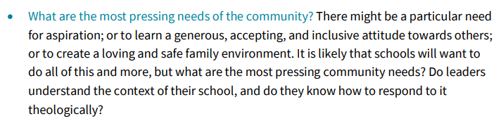

Inspection Questions: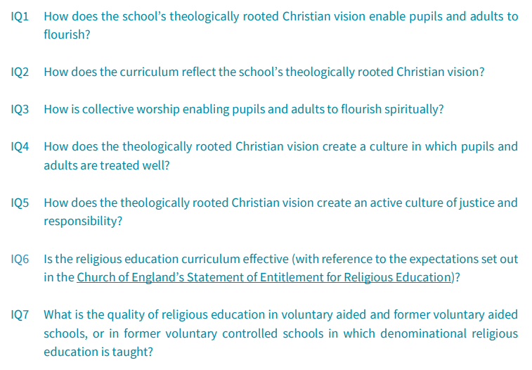
LANDSCOVE C OF E PRIMARY SCHOOL
Academy Head Report for the School Ethos Group

PUPIL NUMBERS

R 15
Y1 13
Y2 16
Y3 13
Y4 13
Y5 7
Y6 12
Total 89

CLASS ORGANISATION
Class 1 : R (0.4 Rebecca Barons, 0.6 Jo Woods)
Class 2: Y1 & Y2 (FT Jenny Foster)
Class 3: Y3 & Y4 (Luke Ansermoz FT)
Class 4: Y5 & Y6 (0.5 Anna Neville, 0.5 Anne Smart)

Amanda Richardson covers PPA in Classes 2 & 3 on a Friday.

STAFFING UPDATES
Rosina Kellman has joined us to be the SENDCo for our school. She will be here on a Tuesday each week. She is highly experienced and works for 3 Trust schools in the same role.
SCHOOL IMPROVEMENT PLAN & SCHOOL SELF EVALUATION:
Staff meetings this term have been/are lined linked to our school improvement plan. The following areas will or have been looked at in depth this half term:
- Science curriculum plans have been updated
- Maths planning for early career teachers - sharing best practice
- KS1 SATS and moderation preparation
- Writing conferencing – for accelerated progress
- DT. Curriculum plan review
- MATHS update
- Moderation of history & geography books

OTHER INFORMATION – VISITORS - COURSES ETC
- 8.12.22 Jenny Foster completed KS1 statutory assessment training
- 6.1.23 KS2 swimming began
- 10.1.23 Musical instrument loan delivery – 32 drums!
- 11.1.23 Rev Gina to discuss/Q&A on her beliefs and world views
- 16.1.23 JR & Jo Woods completed drop in observations of English – writing. This aids continued focus and shared best practice
- 18.1.23 Anne Smart & Anna Neville completed KS1 statutory assessment training
- 20.1.23 Sophie Drew completed Precision teaching training
- 26.1.23 Y3/4 from Landscove & Broadhempston visited Kents Cavern – linked to topic work in science and history
- 27.1.23 Jo Woods completed an English learning walk at Broadhempston
- 2.2.23 Rich Charley, Trust Maths lead, completed a maths learning walk with Karen Barlow
- 7.2.23 Safer Internet day
- Andy Kaey ( standards and outcomes Trust lead) to hold a learn, support and challenge morning with Jill looking at school data to date

HEALTH & SAEFTY/ SAFEGUARDING/ BEHAVIOUR
- JR completed a safeguarding summary report for Trustees at the beginning of January – reporting on the autumn term
- JR & Amanda Grant have completed a tree survey – this is part of our H&S duty.
- All staff have completed working at height training

Safeguarding training this half term is based on:
Revisit of KCSIE, safeguarding crib sheet for all areas – keeping knowledge up to date in all areas, radicalisation, sexual harassment, & INCEL.
Anna Neville & Jill Ryder

